A PROJECT REPORT

ON

**“Web Development On Web”**

VERSION 1.0

FOR

**“Bronx Luggage”**

BY

ANISIUBA MMESOMA BENEDICTA

DAVIES EKE KING Z.

KANU DANIEL CHIBUZOR

KINGSMAN TYNDALE CHUKWUEMEKA

DEPARTMENT OF SOFTWARE ENGINEERING

APTECH, ENUGU STATE BRANCH, NIGERIA

*[2023]*

- ACKNOWLEDGEMENT -

We would like to express our immense gratitude to all those who have contributed to the successful completion of this project.

First and foremost, we would express our heartfelt gratitude to God for granting us wisdom, resources and strength to successfully complete this eProject. We recognize that everything we have accomplished is ultimately due to His grace, and we are humbled and grateful for His provision throughout this entire process.

Secondly, we would like to thank our mentors and instructors who have provided us with invaluable support, guidance and encouragement . We would also like to extend our appreciation to the staff and faculty of Aptech, Enugu State, Nigeria who provided us with the intellectual resources necessary for completing this project.

We are also grateful to our family for their encouragement and understanding during the course of this project. Their support helped us to stay focused and motivated throughout the process.

Lastly, we would like to thank each other for the collaborative effort and teamwork that made this project a success. Our different skills and perspectives came together to create a final product that we are proud of.

Thank you all once again for your contributions made to this project.

Yours sincerely,

ANISIUBA MMESOMA BENEDICTA

DAVIES EKE KING Z.

KANU DANIEL CHIBUZOR

KINGSMAN TYNDALE CHUKWUEMEKA

- TABLE OF CONTENT -

1. eProject Problem Statement
2. Project Specification
3. Project Synopsis
4. Project Analysis
5. Project Design (Pseudo-code and Flowchart design)
6. Web-site Screenshots
7. Source code with comments
8. User Guide
9. Developer’s Guide

- eProject Project Problem Statement -

The beauty of receiving high quality luggage is a truly amazing feeling. Great luggage can be passed down from family members who are experienced travelers. A high-quality set of luggage will last a lifetime.

Bronx Luggage, located in the Festival Marketplace, offers a wide selection of luggage from affordable sets to the best brands on the market for all of your travel needs. We also stock Backpacks, travel accessories, briefcases and much more.

You are supposed to create a Single-Page-Application and responsive Website for them with the below mentioned requirement specifications.

The website is to be developed for the Windows Platform using HTML5, JSON, Angular JS, JavaScript and Geolocation. The site should work well in all leading browsers including Chrome, IE and Firefox etc.

-Project Specification -

The portal will be designed as a Single-Page-Application and responsive Website with a set of pages and menus that represent choice of activities to be performed. The pages, menus, and other visual elements must be designed in a visually appealing manner with attractive fonts, colors, and animations.

All of these should also be laid out in a responsive manner

The Web site is to be created based on the following requirements.

1. The Home Page should be created making use of Sections with a suitable logo, the header section can be added which will show images of various Luggage’s and Bags.
2. The site must contain the sections to navigate through various types of Luggage, Bags and BackPacks etc.
3. Filter for various sizes, colour, price, brands should be provided.
4. Site should have different section for Men and Women with products placed accordingly.
5. Specification and Pricing of Bags should be added along with the images.
6. Website should provide section for various brands offered in the store.
7. Ratings by the user for products should be allowed by the user.
8. Gallery section should be added for viewing different images.
9. Feedback must be allowed to enter by the viewer.

10) Gallery, about us, Contact us link must be added.

11) About Us and Contact Us: This menu option should display Email id, address, and contact number of the organization who is developing the system.

Over and above this, the portal should implement the following functionalities:

* Display a continuous scrolling ticker at the bottom of the page with current date, time, and location (hint: Use geolocation features of HTML5).
* Display a visitor count at the top right corner of the page beside a logo image.
* The menu options should change color on hover and also after clicking.

Fade in and fade out options can be used for the menus.

- SYNOPSIS -

Introduction:

The world is full of adventure and wonder, and there is no better way to explore it than with high-quality luggage that can keep up with your every move. Bronx Luggage is an affordable store that offers high-quality luggage and travel accessories for the modern-day traveler. Our website aims to create an engaging and interactive user experience, catered to the target audience, and optimized for all devices.

Objective:

The objective of this website project is to create a user-friendly and engaging online platform that caters to the needs of its target audience. To achieve this, the website will be developed using the latest technologies and best practices in web design and development. The design and layout of the website will be user-focused and optimized for responsiveness to ensure a seamless experience across all platforms.

The website will also provide a range of functionalities to enable users to navigate and access information easily. These include a search bar, navigation menu, and a feedback and FAQ section to provide instant support and assistance. Social features such as ratings and reviews will also be integrated to enhance the user experience.

To drive traffic and achieve measurable results, the website will be optimized for search engines with a focus on keywords and metadata. The success of the project will be measured through metrics such as website traffic, engagement, conversion rates, and revenue. The site will be regularly updated and maintained to ensure that it remains relevant and effective in achieving its objectives.

In summary, the goal of this website project is to create a user-friendly and engaging platform that caters to the needs of its target audience, drives traffic, and achieves measurable results. The site will be optimized for all devices and feature a range of functionalities to make it easy for visitors to access the information they need.

Methodology:

Our systematic methodology includes gathering requirements from the client, designing and planning the web application, selecting the right technology, developing the front-end and back-end, testing, delivering the application, and providing ongoing maintenance. The website will be developed as a Single-Page-Application using HTML5, JSON, Angular JS, JavaScript, and Geo-location. It will be designed to work well in all leading browsers, including Chrome, IE, and Firefox, and will be responsive and accessible on most devices.

Design:

The website will feature a modern and attractive design with visually appealing elements, such as high-quality images and animations. The layout will be user-friendly, with clear navigation menus and intuitive user interfaces. The website will also feature a search bar that will allow users to search for specific products and a shopping cart that will enable them to purchase items online.It will also contain a feature for the rating of products, gallery, an area for FAQ’s and a feedback section for the customer’s to drop their reviews.

Functionality:

The website will provide customers with a range of functionalities, including the ability to browse products by category, view detailed product information, view items in the gallery, view different bags on the homepage in a pleasant, give ratings and reviews and add items to their shopping cart.

Conclusion:

The development of a responsive and user-friendly website for Bronx Luggage will provide customers with a convenient and accessible way to shop for luggage and other travel accessories online. By providing customers with a range of functionalities and an attractive design, we aim to increase online sales and drive more traffic to the physical store.

- ANALYSIS -

Introduction:

Bronx Luggage, a retailer of luggage and travel accessories located in the Festival Marketplace, is seeking a new website to promote their products and provide customers with an easy-to-use online shopping experience. This project analysis outlines the requirements and specifications for a Single-Page-Application (SPA) and responsive website for Bronx Luggage.

Methodology:

The development of the website will be guided by a user-centered design approach, focusing on creating a visually appealing design that is easy to navigate and optimized for use on all major browsers, including Chrome, IE, and Firefox. The website will be developed using HTML5, JSON, Angular JS, JavaScript and Geolocation, JQuery and CSS, with a focus on delivering a fast and responsive user experience. The website will be tested across various devices and browsers to ensure compatibility.

The website will be developed in accordance with the functional requirements outlined below.

FUNCTIONAL REQUIREMENTS:

**Single-Page-Application and Responsive Design:**

The website will be designed as a SPA with a responsive layout that adjusts to the size of the user's screen. The design will be visually appealing with attractive fonts, colors, and animations to enhance the user experience. The website's design will incorporate a consistent theme and branding that reflects Bronx Luggage's identity and values.

**Navigation and Menus:**

The website's navigation and menus will be intuitive and user-friendly, providing clear and concise labels for each section of the site. The menus will be accessible from any page on the site, allowing users to easily browse products and find what they are looking for.

**Product Catalog:**

The website will feature a product catalog with a wide selection of luggage and travel accessories, including affordable sets and premium brands. Each product will be accompanied by high-quality images and detailed descriptions to help users make informed purchasing decisions. The website will provide users with the ability to filter and sort products based on various criteria, such as price, brand, and rating.

**Shopping Cart and Checkout:**

The website will include a shopping cart and checkout process that is easy to use and secure. Users will be able to add items to their cart, view their cart, and proceed to checkout with a few simple clicks.

**Geo-location:**

The website will use geo-location to provide users with localized information about their locations.

Findings:

Based on the requirements outlined above, the development of a responsive SPA using modern web technologies, such as AngularJS, is the ideal solution for Bronx Luggage's website needs. The website's design and functionality will provide users with a seamless and engaging shopping experience, driving sales and improving customer satisfaction.

Conclusion:

In conclusion, the development of a Single-Page-Application and responsive website for Bronx Luggage will provide the retailer with an online presence that is optimized for use on all major browsers and devices. By incorporating geo-location and other advanced features, we can create a site that meets the needs of modern travelers and provides a seamless shopping experience. The user-centered design approach and the use of modern web technologies will ensure that the website is easy to use, visually appealing, and optimized for performance.

- PROJECT DESIGN -

Creating user-friendly and efficient web-page applications is essential in today's constantly evolving world of web development. One technique that can help achieve this is the use of flowcharts and pseudocode. Flowcharts provide a visual representation of the steps involved in a process, while pseudocode allows developers to write code in a more human-readable format.

In this chapter, we present the flowchart and pseudocode design of our web-page application. Our design includes a user-friendly navigation system, intuitive product display, efficient shopping cart functionality, and the ability for users to rate and review products. By using these design tools, we planned out the application's logic and ensured a seamless user experience.

Our chapter aims to provide valuable insights into the design process of our web application using flowcharts and pseudocode. By exploring the advantages of these design tools, we created a user-friendly and efficient web application. Let's delve into the world of flowcharts and pseudocode to see our web application design!

PSEUDOCODE

In this pseudocode, we'll outline the basic flow of a web application that includes different sections for men, women, accessories, and gallery. Additionally, we'll include options for filtering products within each section and adding products to a shopping cart. Finally, we'll include sections for About Us, Contact Us, and FAQ.

start:

Display landing page;

if (user clicks on "Men" button) then (Yes)

Display men's section;

if (user clicks on a sub-category) then (Yes)

Display products in selected sub-category;

if (user clicks on a product) then (Yes)

Display product details;

if (user clicks on "Add to Cart" button) then (Yes)

Add product to shopping cart;

Display shopping cart contents;

endif

if (user clicks on "star" icon) then (Yes)

Display star rating form;

if (user submits rating) then (Yes)

Update product rating;

Display rating confirmation message;

else (No)

Return to product details page;

endif

endif

else (No)

Return to products page;

endif

else (No)

Return to men's section page;

endif

elseif (user clicks on "Women" button) then (Yes)

Display women's section;

if (user clicks on a sub-category) then (Yes)

Display products in selected sub-category;

if (user clicks on a product) then (Yes)

Display product details;

if (user clicks on "Add to Cart" button) then (Yes)

Add product to shopping cart;

Display shopping cart contents;

endif

if (user clicks on "star" icon) then (Yes)

Display star rating form;

if (user submits rating) then (Yes)

Update product rating;

Display rating confirmation message;

else (No)

Return to product details page;

endif

endif

else (No)

Return to products page;

endif

else (No)

Return to women's section page;

endif

elseif (user clicks on "Accessories" button) then (Yes)

Display accessories section;

if (user clicks on a sub-category) then (Yes)

Display products in selected sub-category;

if (user clicks on a product) then (Yes)

Display product details;

if (user clicks on "Add to Cart" button) then (Yes)

Add product to shopping cart;

Display shopping cart contents;

endif

if (user clicks on "star" icon) then (Yes)

Display star rating form;

if (user submits rating) then (Yes)

Update product rating;

Display rating confirmation message;

else (No)

Return to product details page;

endif

endif

else (No)

Return to products page;

endif

else (No)

Return to accessories section page;

endif

elseif (user clicks on "Gallery" button) then (Yes)

Display gallery section;

if (user clicks on a sub-category) then (Yes)

Display images in selected sub-category;

if (user clicks on an image) then (Yes)

Display image details;

else (No)

Return to gallery page;

endif

else (No)

Return to gallery page;

endif

elseif (user clicks on "About Us" button) then (Yes)

Scroll to "About Us" section on landing page;

elseif (user clicks on "Contact Us" button) then (Yes)

Scroll to "Contact Us" section on landing page;

elseif (user clicks on "FAQ" button) then (Yes)

Display FAQ page;

if (user clicks on a question) then (Yes)

Display answer to selected question;

else (No)

Return to FAQ page;

endif

else

Display landing page;

endif

stop

FLOWCHART

In web development, flowcharts can be used to map out the user's journey through a website or application, providing a clear understanding of how different pages and components are

interconnected. Here's a flowchart diagram illustrating the user journey for our web application which was drawn using ‘Canva’.

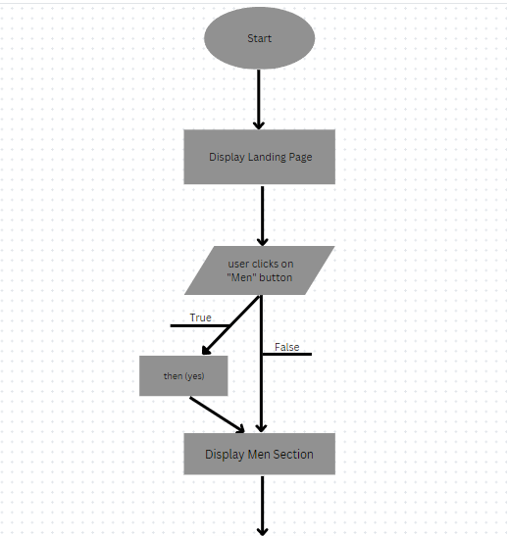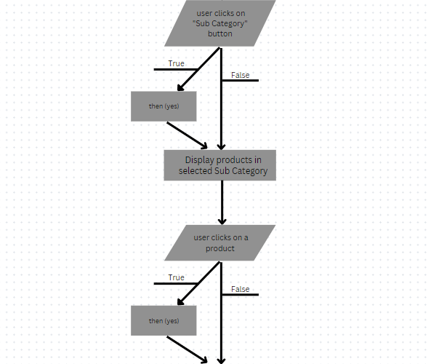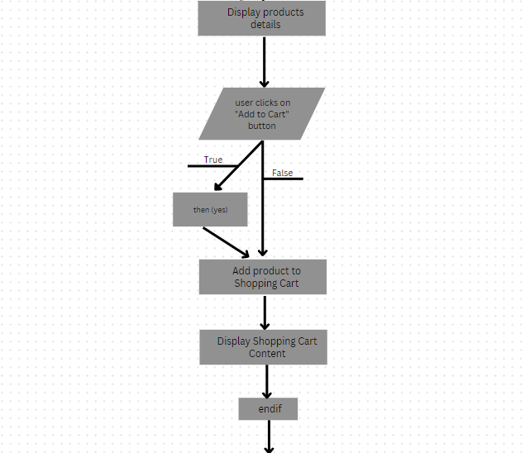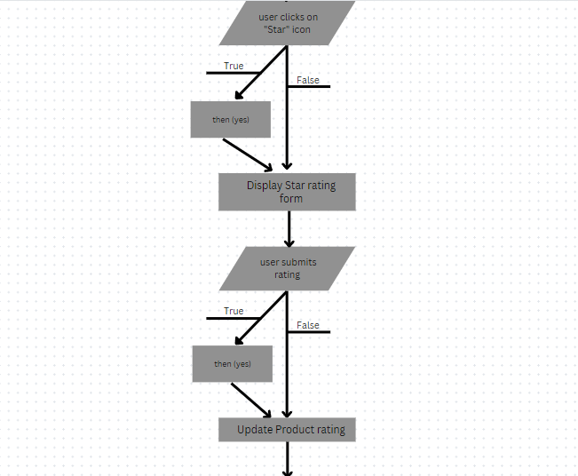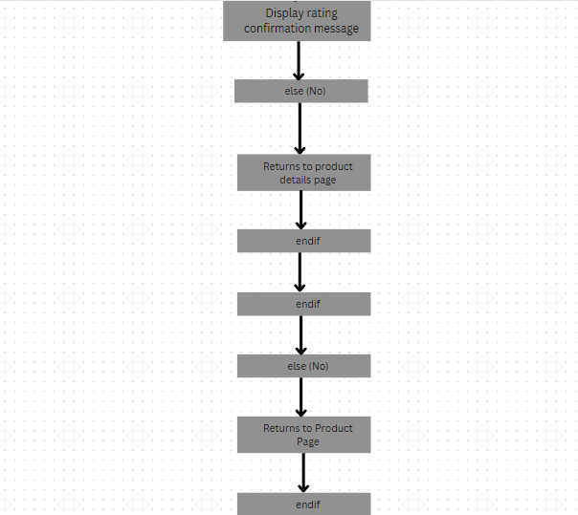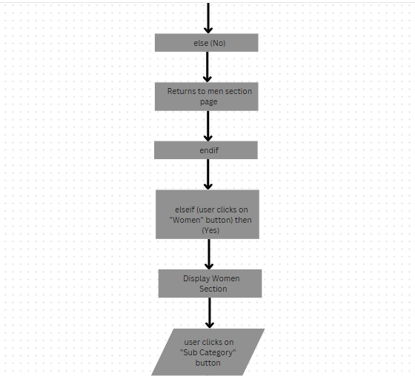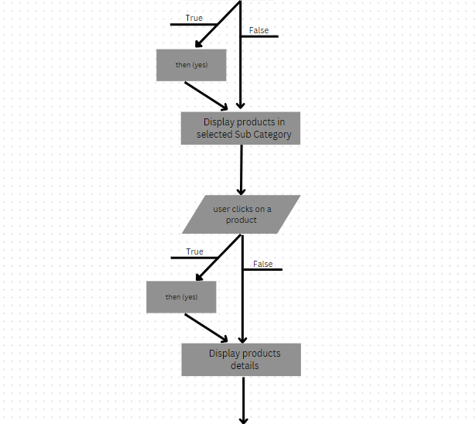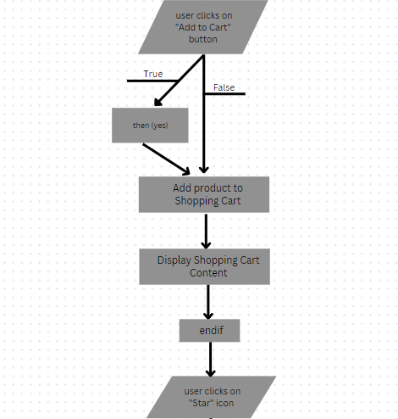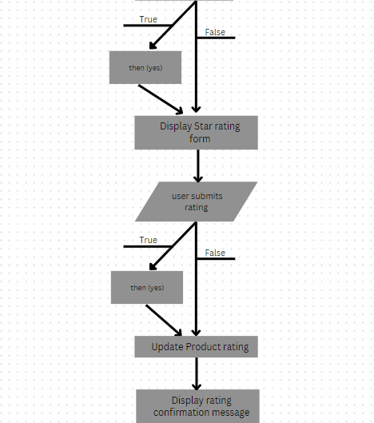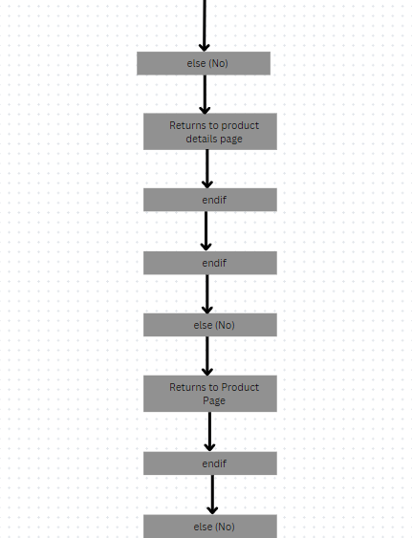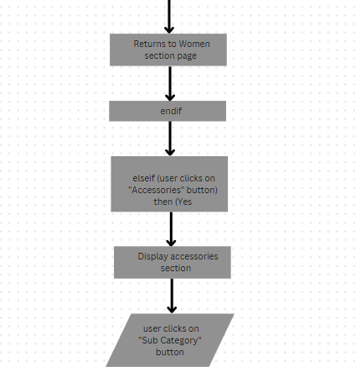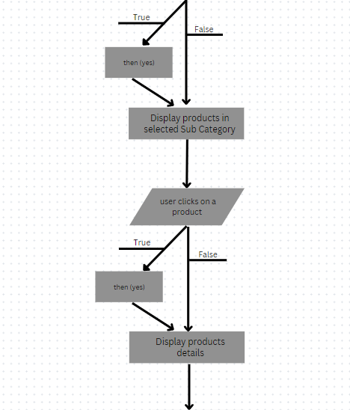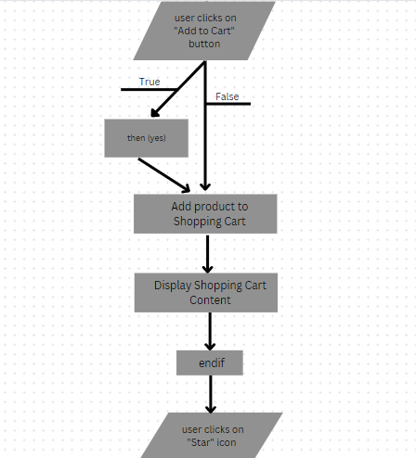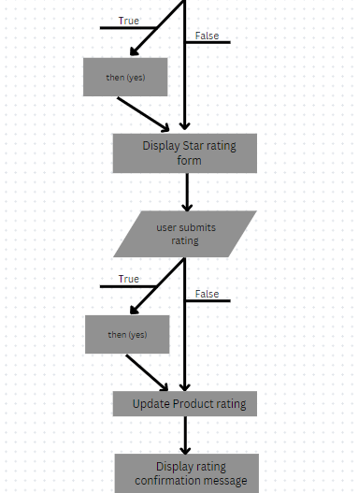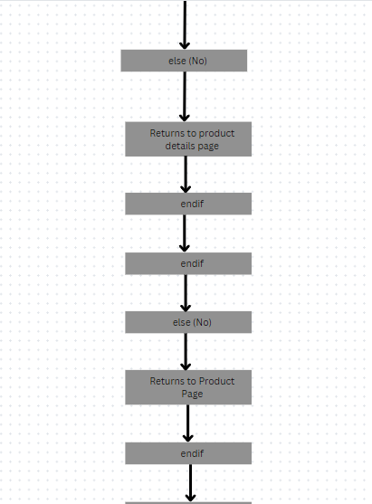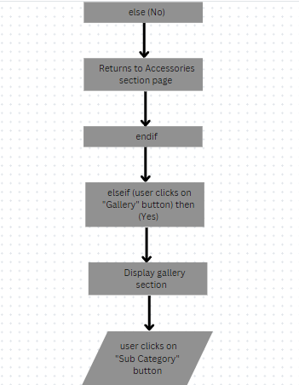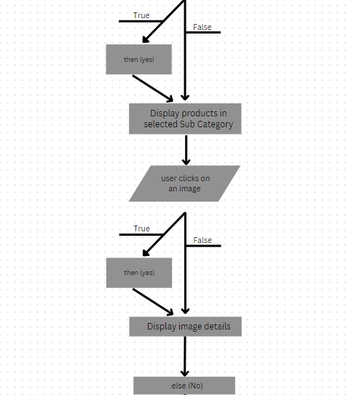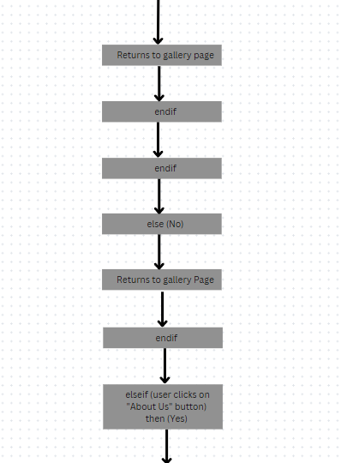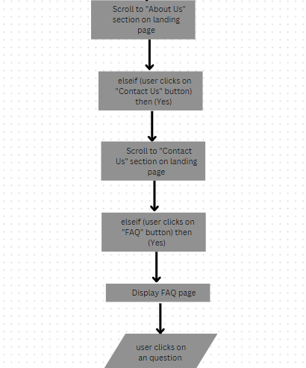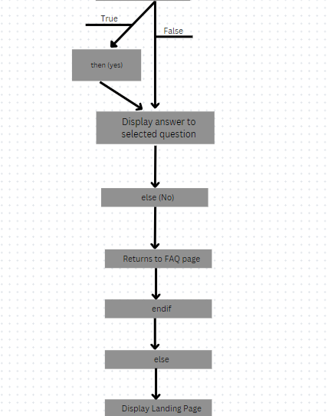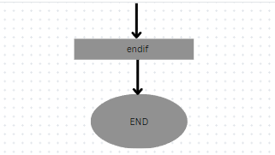

And this brings you to the end of the flowchart design.

- WEBSITE SCREENSHOT -

The screenshots below are a visual context of the website we built and we hope you too find it visually appealing.

The pictures, that will be first seen are of those of the homepage.

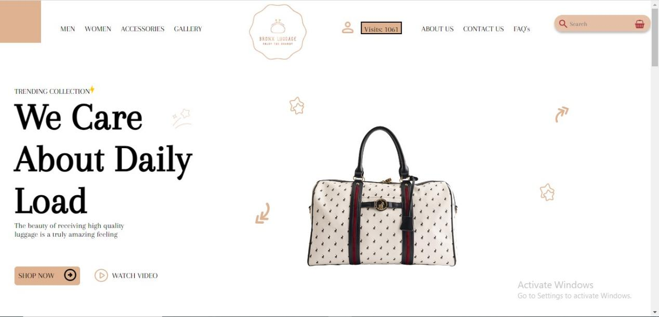

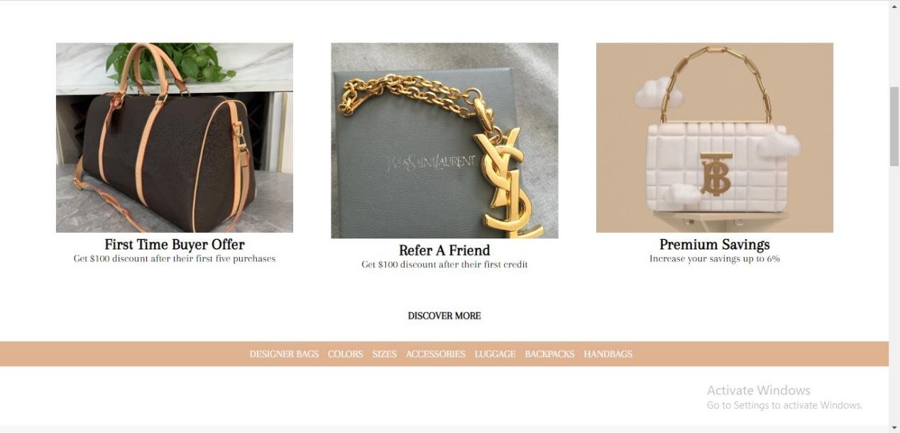

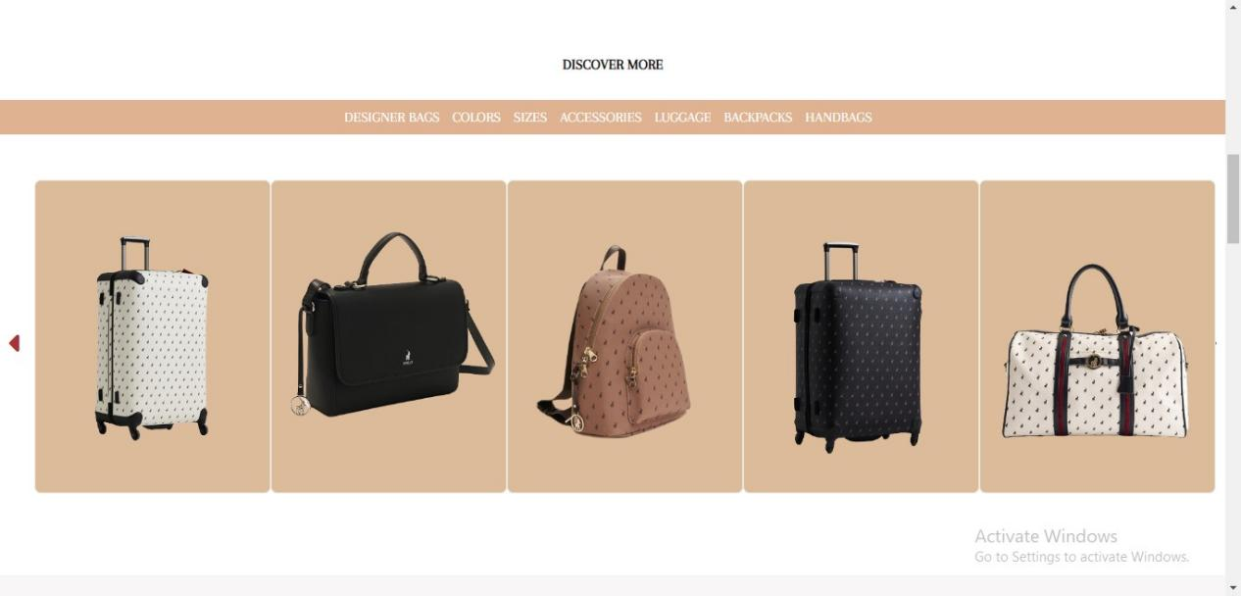

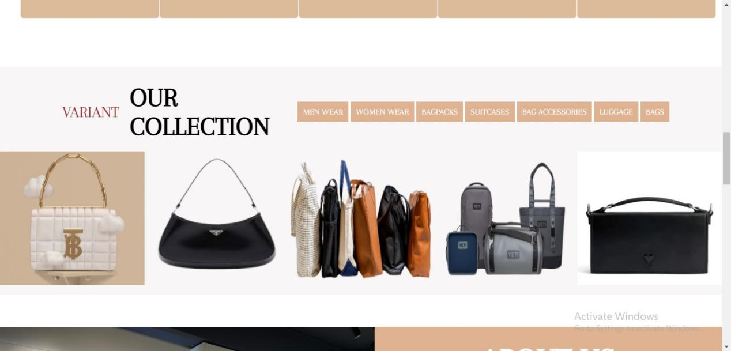

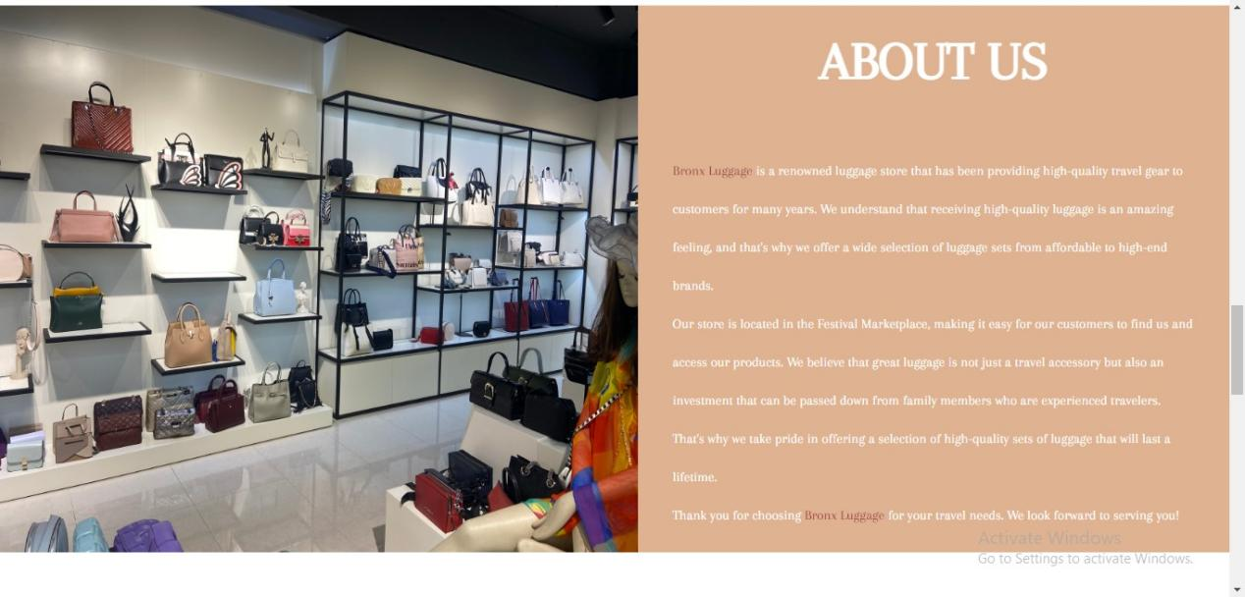

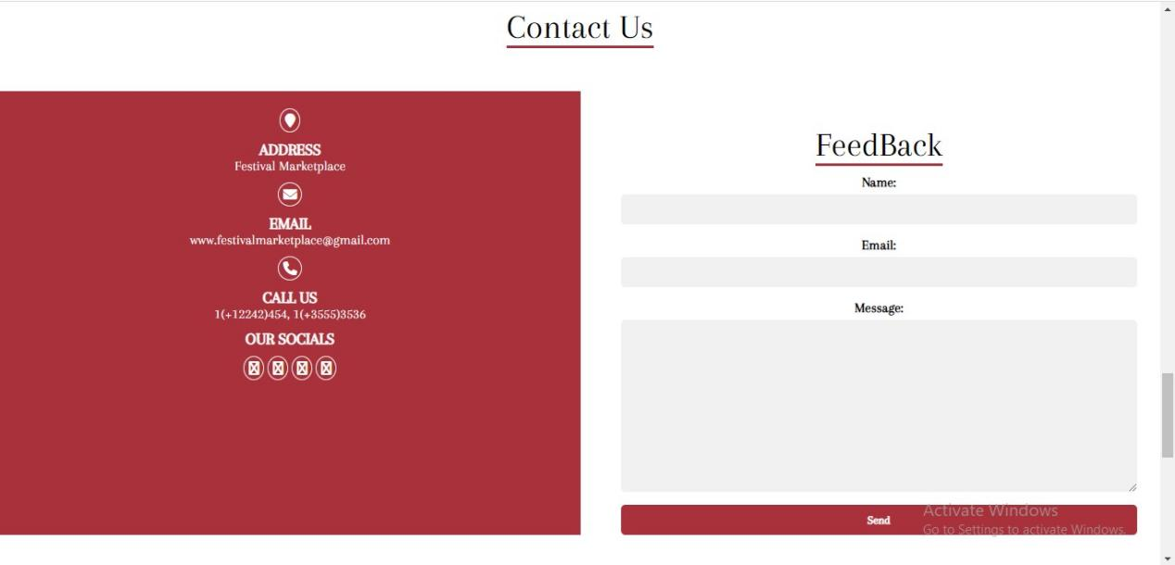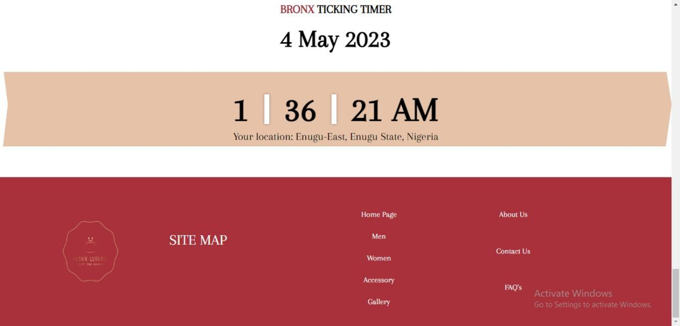

(The api used to fetch the data for current location at times takes time to be very accurate , it might display a location close to you but with time, it adjusts and becomes very accurate so please be patient).

The next set of screenshot is for the menu pages. The men, women and accessories have similar structure so I will display the first section of each of their pages which has a bit of difference but I will use the women page to show the general view of each of them looks.

The men’s page first view:

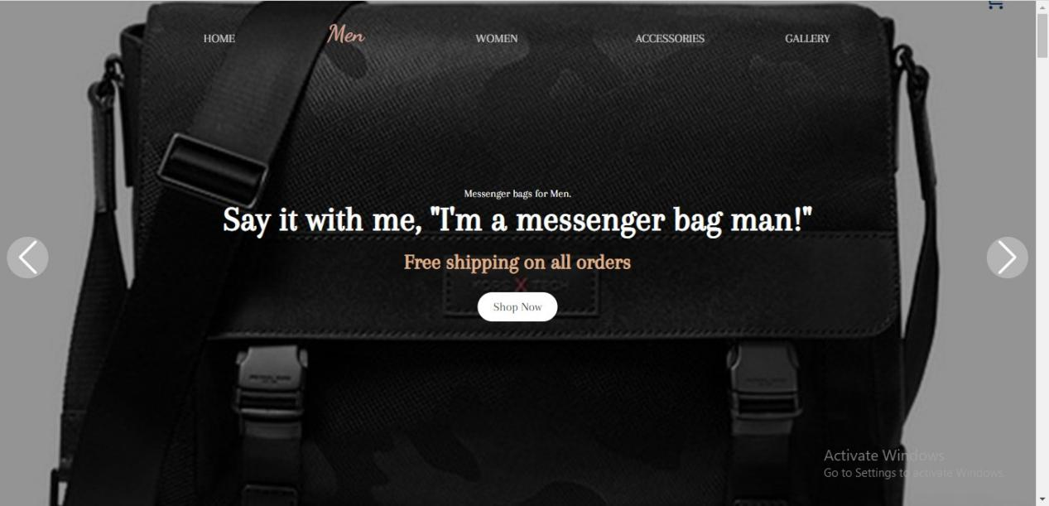

First view of the women page:

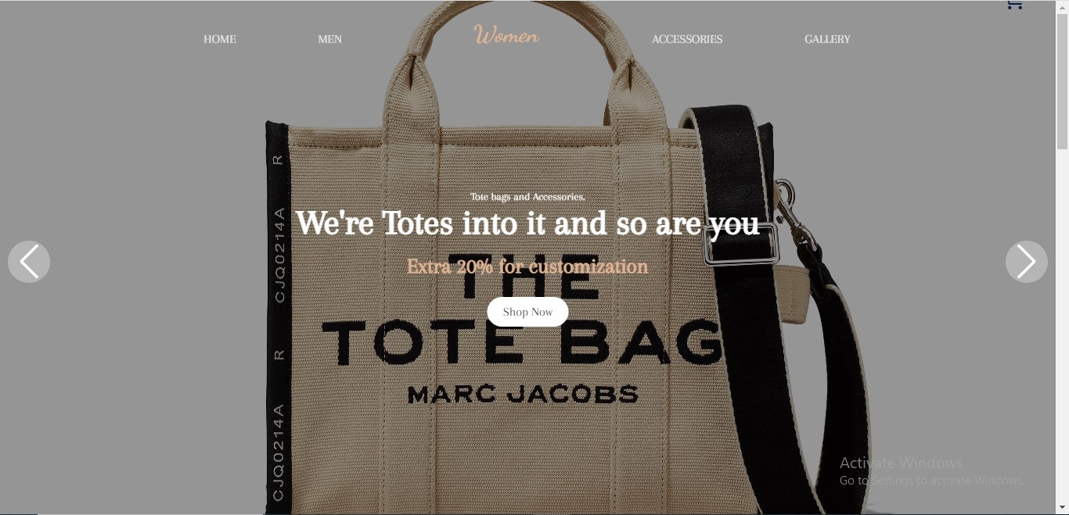

First view of the accessory page:

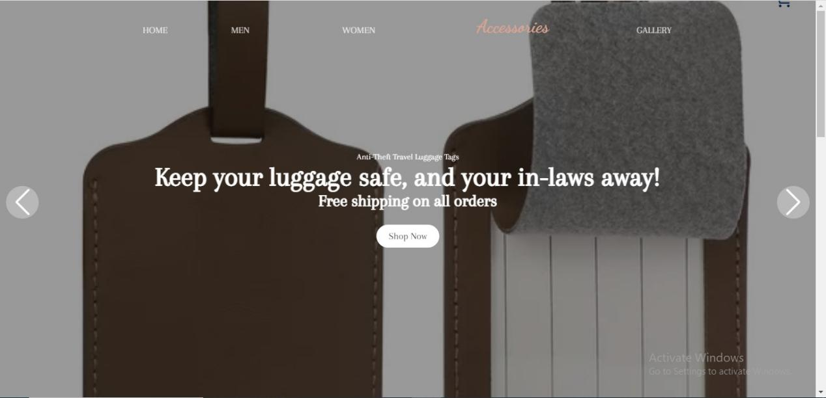

Then is is what the rest of their pages look like after the first view but I am using the women page to represent the three of them because they have similar structure but starting again with its first view.

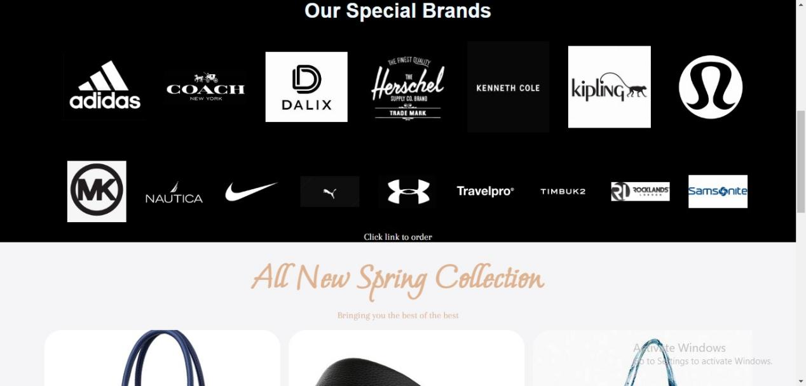

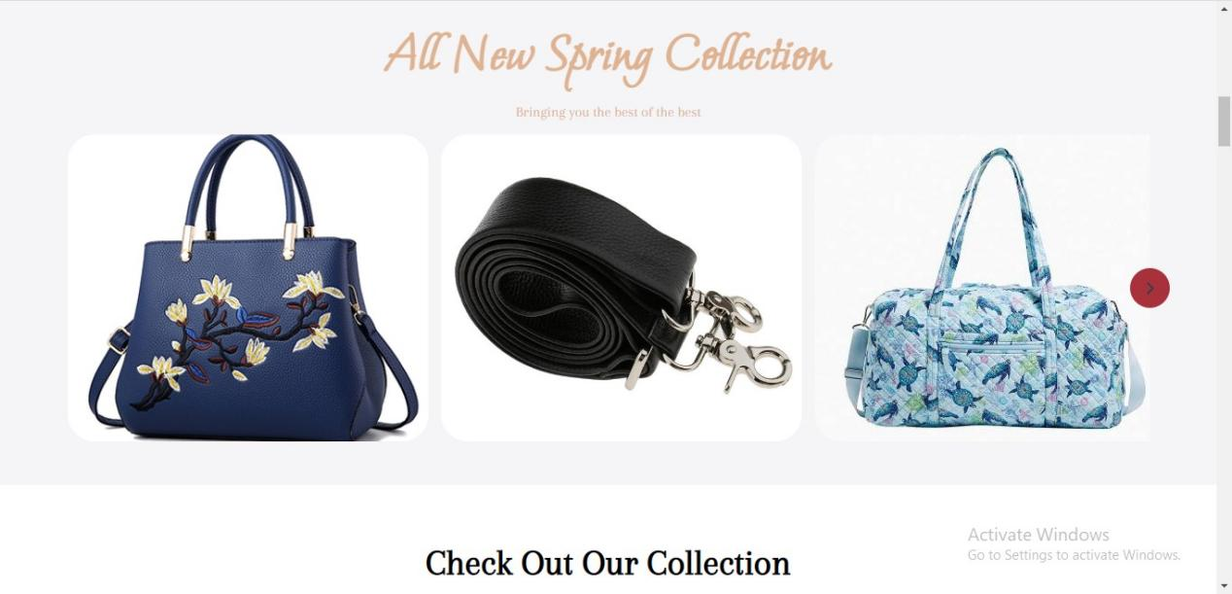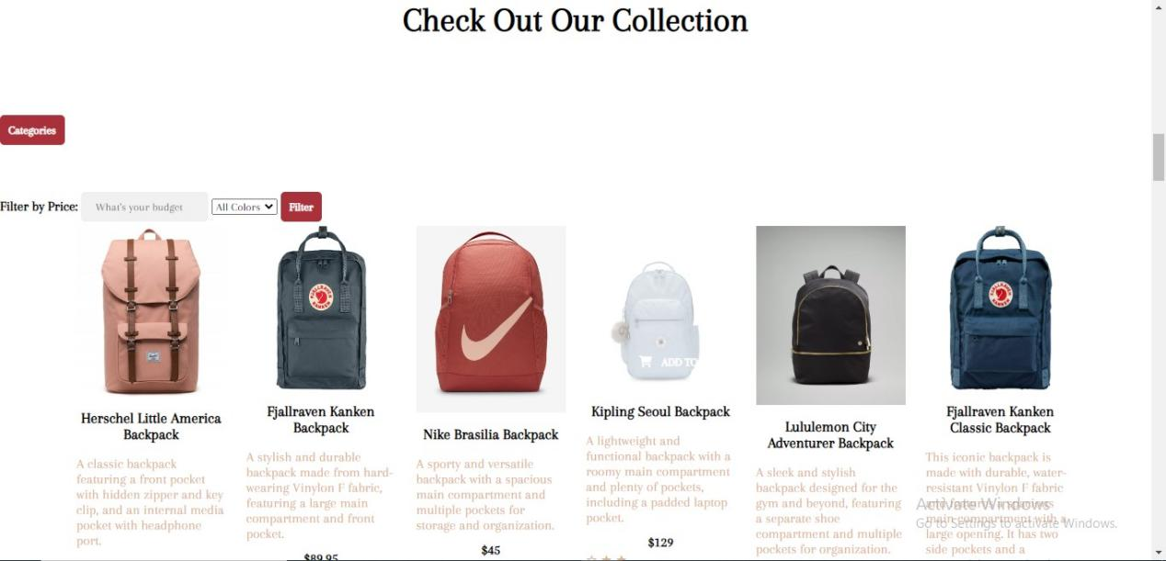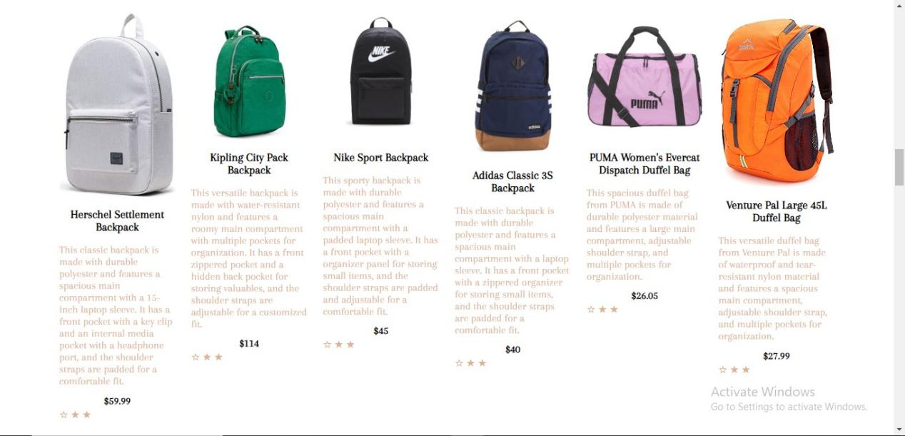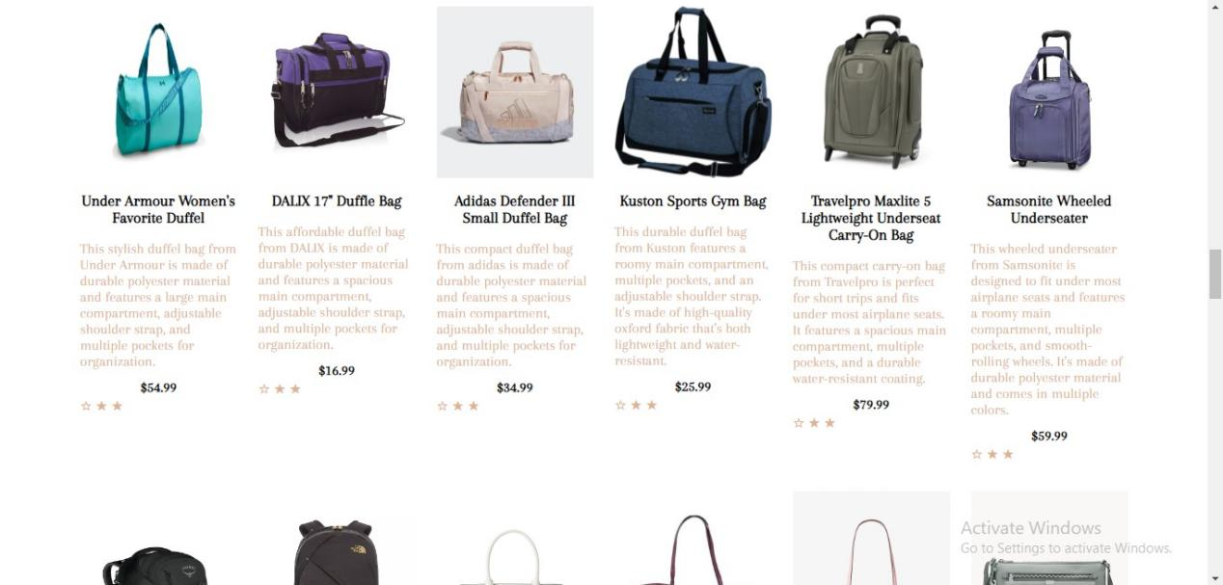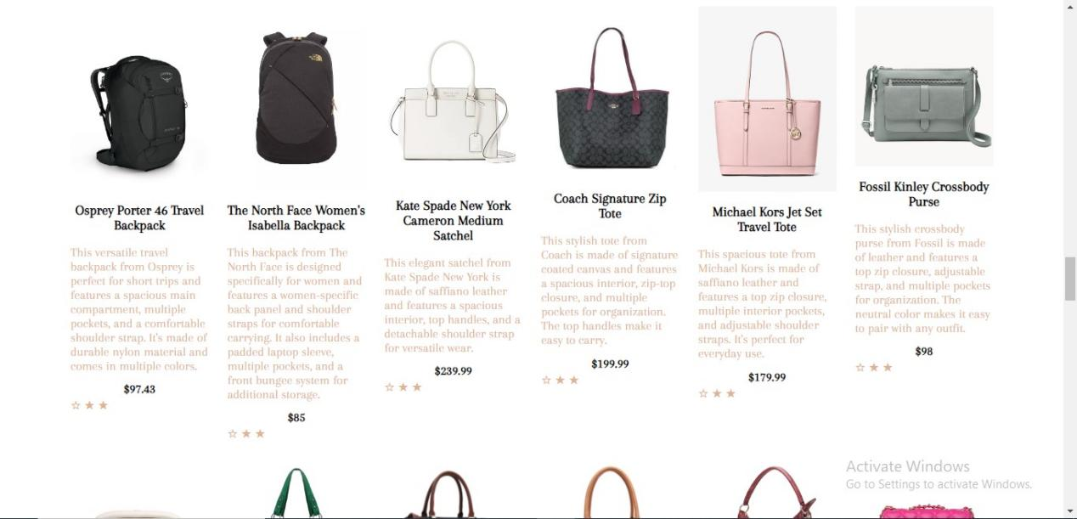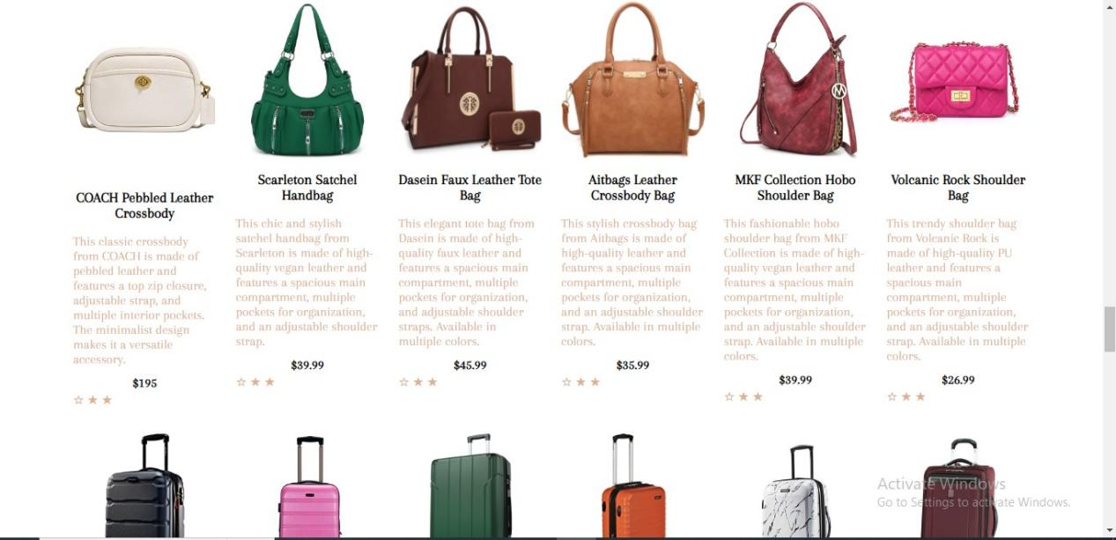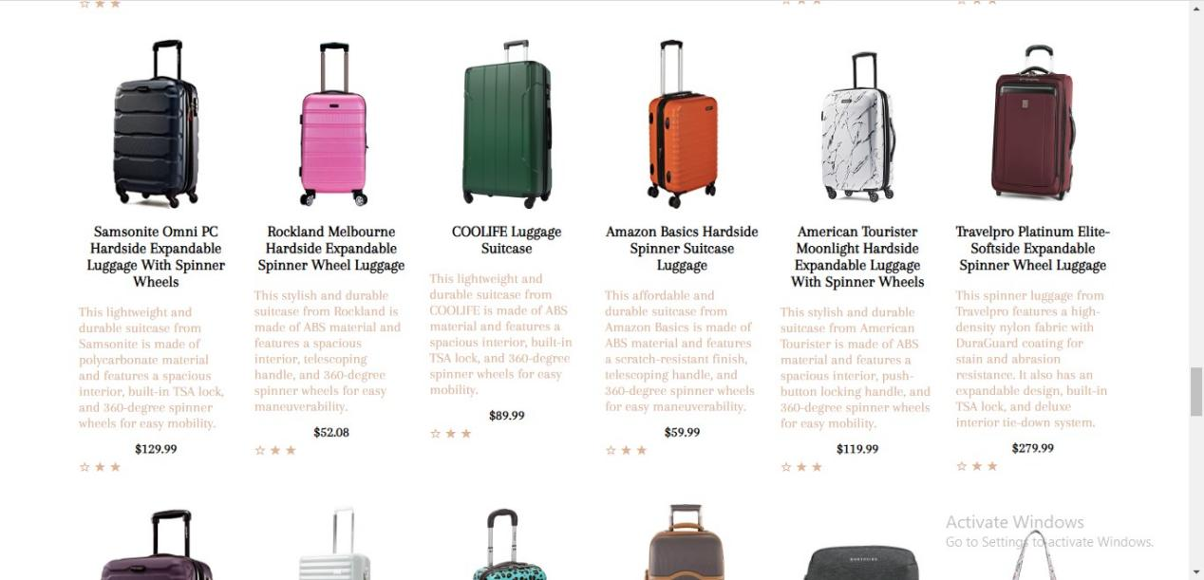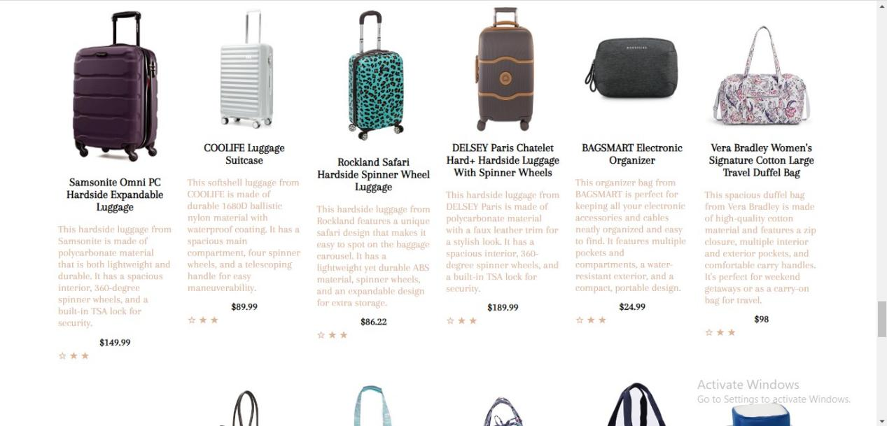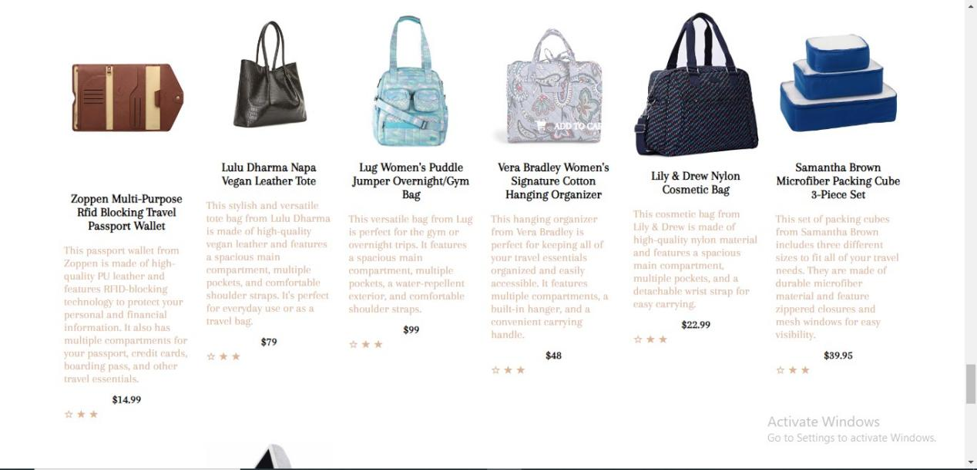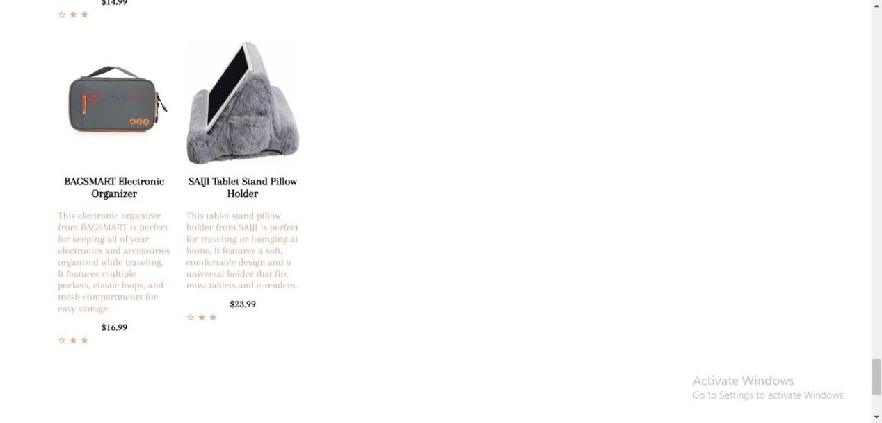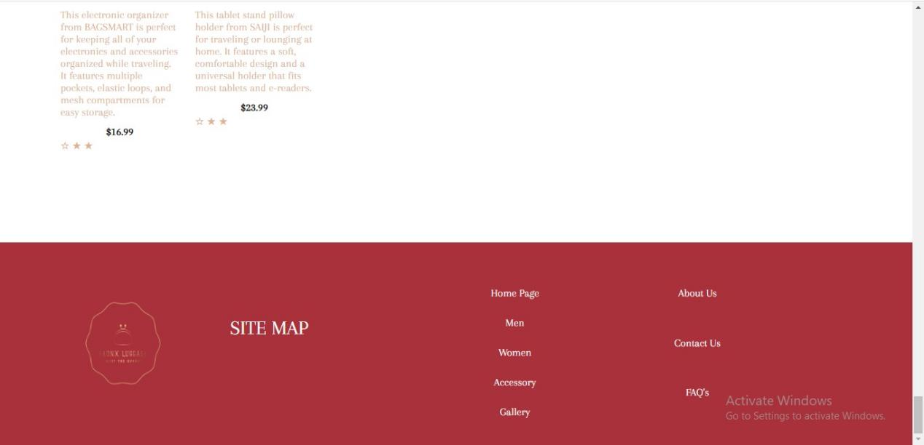

Then these last next two are the gallery and faq pages consecutively.

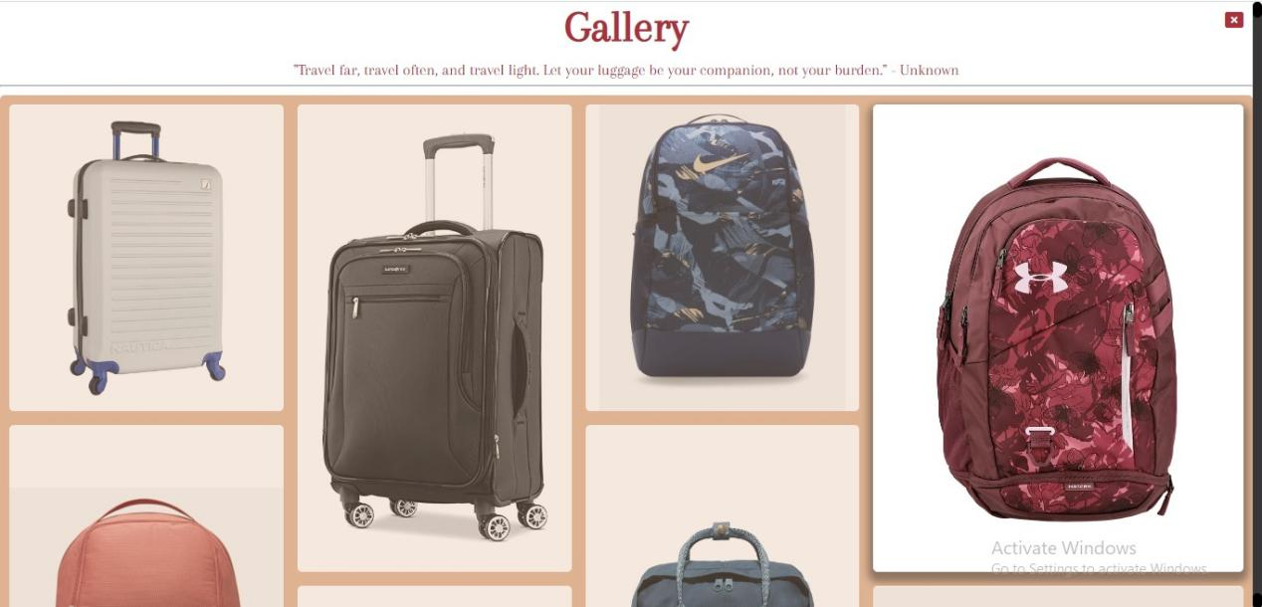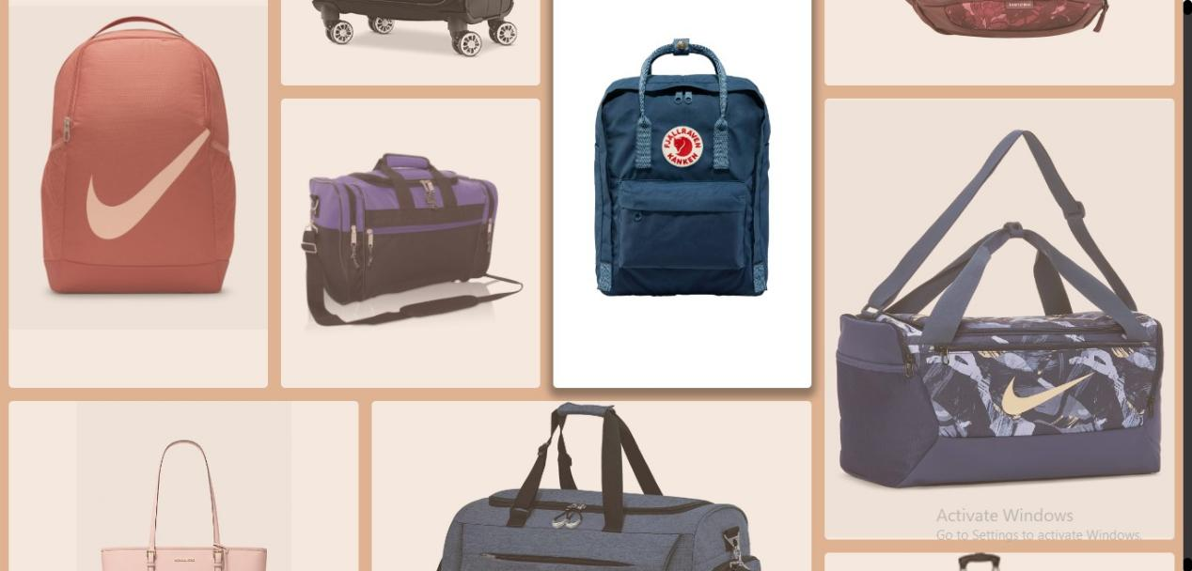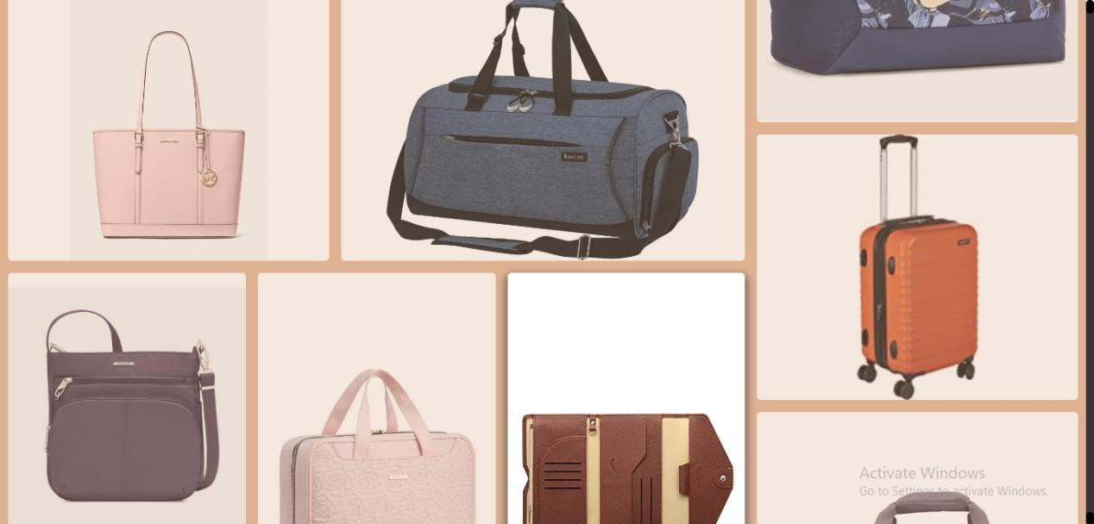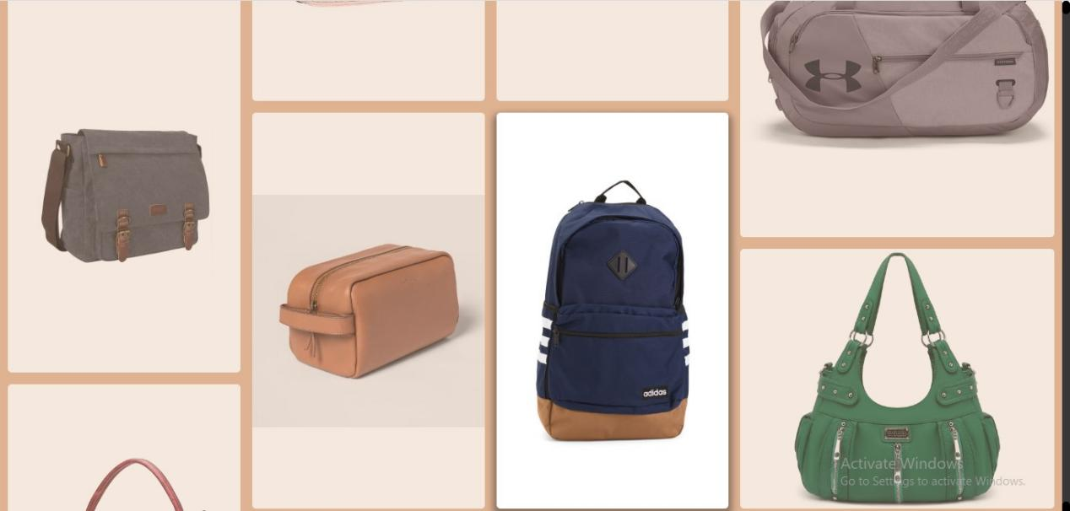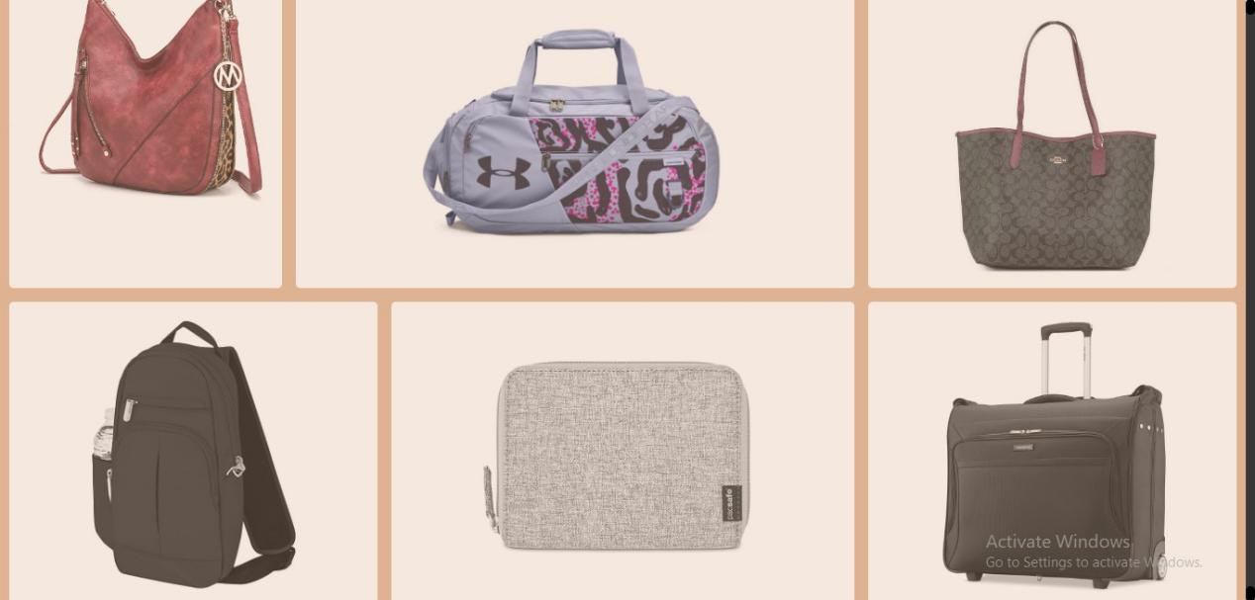

The faq page:

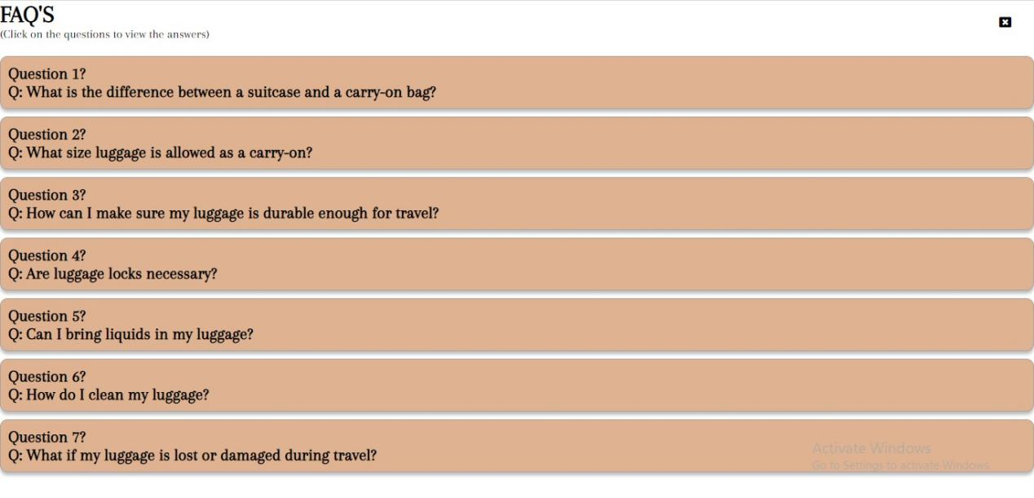

- CODE SCREENSHOT -

Index.html page

<!DOCTYPE html>

<html lang="en">

<head>

    <meta charset="UTF-8">

    <meta http-equiv="X-UA-Compatible" content="IE=edge">

    <meta name="viewport" content="width=device-width, initial-scale=1.0">

    <title>Bronx Luggage</title>

    <link rel="icon" type="image/x-icon" href="Photos/Bronx Logo.png">

    <link rel="stylesheet" href="./style.css">

    <link rel="stylesheet" href="../Bronx Luggage/E proj/css/swiper-bundle.min.css" />

    <link rel="stylesheet" href="https://cdnjs.cloudflare.com/ajax/libs/font-awesome/4.7.0/css/font-awesome.min.css">

    <link rel="stylesheet" href="https://cdnjs.cloudflare.com/ajax/libs/font-awesome/6.2.0/css/all.min.css">

    <!-- Owl Carousel CSS -->

    <link rel="stylesheet" href="./dist/assets/owl.carousel.min.css">

    <link rel="stylesheet" href="./dist/assets/owl.theme.default.css">

    <!-- Google Font -->

    <link rel="preconnect" href="https://fonts.googleapis.com">

    <link rel="preconnect" href="https://fonts.gstatic.com" crossorigin>

    <link href="https://fonts.googleapis.com/css2?family=Arapey&display=swap" rel="stylesheet">

    <link href="https://fonts.googleapis.com/css2?family=Arapey&display=swap" rel="stylesheet">

    <link href="https://fonts.googleapis.com/css2?family=Moon+Dance&family=Satisfy&display=swap" rel="stylesheet">

    <!-- jQuery -->

    <script src="js_files/jquery.js"></script>

    <!-- Owl Carousel JavaScript -->

    <script src="./dist/owl.carousel.min.js"></script>

    <!-- My JS Files -->

    <script src="js_files/angular.min.js"></script>

    <script src="js_files/angular-router.js"></script>

    <link rel="stylesheet" href="https://cdn.jsdelivr.net/npm/swiper@9/swiper-bundle.min.css"/>

    <script src="https://cdn.jsdelivr.net/npm/swiper@9/swiper-bundle.min.js"></script>

   <style>

    @import url('https://fonts.googleapis.com/css2?family=Dancing+Script:wght@700&display=swap');

    @import url('https://fonts.googleapis.com/css2?family=Moon+Dance&display=swap');

  </style>

</head>

<body ng-app="module" ng-controller="myController">

 <div ng-view></div>

 <script src="js_files/angular.js"></script>

</body>

</html>

Homepage html

    <div class="container">

        <!-- I declared the controller in this frame and this controller in the nav bar is to navigate to a div on click -->

       <div class="landingpage_frame1" >

            <header>

                <!-- These first two spans are for the box on the top right psge of the website -->

                <span class="main-box"><span class="mini- box"></span></span>

                <nav class="menu">

                    <div class="dropdown">

                    <a href="#!men" ng-click="refreshPage()" class="nav">MEN</a>

                    <div class="dropdown-content">

                        <a href="">Backpacks</a>

                        <a href="">Duffel Bags</a>

                        <a href="">Messenger Bags</a>

                        <a href="">Suitcases</a>

                        <a href="">Travel Accessories</a>

                    </div>

                    </div>

                    <div class="dropdown">

                    <a href="#!women" ng-click="refreshPage()" class="nav">WOMEN</a>

                    <div class="dropdown-content">

                        <a href="">Backpacks</a>

                        <a href="">Duffel Bags</a>

                        <a href="">Handbags</a>

                        <a href="">Suitcases</a>

                        <a href="">Travel Accessories</a>

                    </div>

                    </div>

                    <div class="dropdown">

                    <a href="#!accessories" ng-click="refreshPage()" class="nav">ACCESSORIES</a>

                    <div class="dropdown-content">

                        <a href="">Luggage Tags</a>

                        <a href="">Locks</a>

                        <a href="">Packing Cubes</a>

                        <a href="">Travel Pillows</a>

                        <a href="">Umbrellas</a>

                    </div>

                    </div>

                    <a href="#!gallery" class="nav">GALLERY</a>

                </nav>

                <!-- This part is after the logo in the header section -->

                <span class="bronxlogo"><img src="Photos/Bronx Logo.png" width="150" alt="BronxLuggage"></span>

                <span class="person"><img src="Photos/person.png" width="24" alt=""></span>

                <!-- This keeps counts of the visits -->

                <span class="visit_counter" my-visit-count></span>

                <!-- The scroll to func is from the angular controller(myControoler) to navigate to another div on click to the specified id -->

                <nav class="menu">

                    <a  ng-click="scrollTo('aboutus')">ABOUT US</a>

                    <a  ng-click="scrollTo('contactus')">CONTACT US</a>

                    <a ng-href="#!faq">FAQ's</a>

                </nav>

                <!-- This is the search bar -->

                <div class="search_bar">

                    <span class="search"><img src="Photos/search.png" width="17" alt=""></span>

                    <input type="text" placeholder="Search">

                    <span class="basket"><img src="Photos/basket.png" width="20" alt=""></span>

                </div>

                <div class="hamburger">

                    <span></span><span></span><span></span>

                </div>

            </header>

            <div class="mid-space">

                <div class="text_bag">

                        <div class="intro_text">

                            <p>TRENDING COLLECTION<span><img src="Photos/lightening.png" width="10" alt=""></span></p>

                            <h1>We Care <span class="shooting_star"><img src="Photos/shooting_star.png" width="40" alt=""></span> <br> About Daily <br> Load </h1>

                            <p>The beauty of receiving high quality <br> luggage is a truly amazing feeling</p>

                        </div>

                        <div class="bags_display">

                            <img src="" alt="">

                        </div>

                </div>

                <div class="frame1_btns">

                        <a href="" class="shop_now"><p>SHOP NOW</p><span><img src="Photos/right_arrow.png" width="25" alt=""></span></a>

                        <a href="" class="watch"><span><img src="Photos/video.png" width="28" alt=""></span><p>WATCH VIDEO</p></a>

                </div>

            </div>

            <div id="image-slider" class="image-display" ng-controller="pictures">

                <img src="Photos/star.png" width="30" class="star" alt="">

                <img src="./Photos/big_arrow.png" width="30" class="big_arrow"></img>

                <img ng-repeat="pic in pic_data" ng-src="{{pic}}" ng-if="$index === currentPicIndex">

                <img src="./Photos/small_arrow.png" width="28" class="small_arrow"></img>

                <img src="Photos/star.png" width="30" class="star2" alt="">

            </div>

        </div>

       <div class="landingpage_frame2">

            <div class="display_section">

                <div class="display">

                    <img src="Pictures/duffel2.png" width="360" alt="">

                    <h2>First Time Buyer Offer</h2>

                    <p>Get $100 discount after their first five purchases</p>

                </div>

                <div class="display">

                    <img src="Pictures/accessory.png" width="460" alt="">

                    <h2>Refer A Friend</h2>

                    <p>Get $100 discount after their first credit</p>

                </div>

                <div class="display">

                    <img src="Pictures/tb.png" width="360" alt="">

                    <h2>Premium Savings</h2>

                    <p>Increase your savings up to 6%</p>

                </div>

            </div>

            <p class="discover">DISCOVER MORE</p>

            <div class="text-plank">

                <div class="text_span">

                    <span>DESIGNER BAGS</span> <span>COLORS</span> <span>SIZES</span> <span>ACCESSORIES</span> <span>LUGGAGE</span> <span>BACKPACKS</span> <span>HANDBAGS</span>

                </div>

                <!-- For the sliding images and their buttons -->

                <button id="prev" class="fa fa-caret-left"></button>

                <div id="pic_slider" class="image-display owl-carousel owl-theme" ng-controller="slider">

                    <div ng-repeat="pic in slider_data">

                        <img ng-src="{{pic}}" >

                    </div>

                </div>

                <button id="next" class="fa fa-caret-right"></button>

            </div>

        </div>

        <!-- This is the div for frame 3 -->

        <div class="landingpage_frame3">

            <div class="head-text">

                <p class="variant">VARIANT</p>

                <h1>OUR <br> COLLECTION</h2>

               <div class="tops">

                    <p >MEN WEAR</p>

                    <p >WOMEN WEAR</p>

                    <p >BAGPACKS</p>

                    <p >SUITCASES</p>

               </div>

                <br>

                <div class="bottoms">

                    <p >BAG ACCESSORIES</p>

                    <p >LUGGAGE</p>

                    <p >BAGS</p>

                </div>

            </div>

            <div ng-controller="slides" id="owl-carousel" class="owl-carousel">

                <div ng-repeat="slide in slides_data" class="item">

                    <img ng-src="{{slide}}" width="120" height="250" alt="slide">

                </div>

            </div>

        </div>

        <div id="aboutus" class="landingpage_frame4">

            <div class="shop_picture">

                <img src="https://sc04.alicdn.com/kf/H9541d320aed446d8ac20625a41bd834df/247976592/H9541d320aed446d8ac20625a41bd834df.jpg" height="600" width="700" alt="">

            </div>

            <div class="about_us">

                <h1>ABOUT US</h1>

                <p>

                    <span>Bronx Luggage</span> is a renowned luggage store that has been providing high-quality travel gear to customers for many years. We understand that receiving high-quality luggage is an amazing feeling, and that's why we offer a wide selection of luggage sets from affordable to high-end brands. <br>

                    Our store is located in the Festival Marketplace, making it easy for our customers to find us and access our products. We believe that great luggage is not just a travel accessory but also an investment that can be passed down from family members who are experienced travelers. That's why we take pride in offering a selection of high-quality sets of luggage that will last a lifetime. <br>

                    Thank you for choosing <span>Bronx Luggage</span> for your travel needs. We look forward to serving you!

                </p>

            </div>

        </div>

        <div class="landingpage_frame5" id="contactus">

            <h1>Contact Us</h1>

            <div class="contact_container">

              <div class="contact_info">

                <div class="address">

                  <i class="fa fa-map-marker"></i>

                  <h3>ADDRESS</h3>

                  <p>Festival Marketplace</p>

                </div>

                <div class="email">

                  <i class="fa fa-envelope"></i>

                  <h3>EMAIL</h3>

                  <p>www.festivalmarketplace@gmail.com</p>

                </div>

                <div class="phone">

                  <i class="fa fa-phone"></i>

                  <h3>CALL US</h3>

                  <p>1(+12242)454, 1(+3555)3536</p>

                </div>

                <div class="socials">

                  <h3>OUR SOCIALS</h3>

                  <a href=""><i class="fa fa-facebook"></i></a>

                  <a href=""><i class="fa fa-twitter"></i></a>

                  <a href=""><i class="fa fa-instagram"></i></a>

                  <a href=""><i class="fa fa-pinterest"></i></a>

                </div>

              </div>

              <div class="feedback_container">

                <h1>FeedBack</h1>

                <!-- What should be in the parameter of this <formspree-email> is the company's actual email or any actual email address incase you want to test it out -->

                <form id="contact-form" method="POST" action="https://formspree.io/f/<formspree-email>" autocomplete="off">

                    <label for="name">Name:</label>

                    <input type="text" id="name" name="name" required>

                    <label for="email">Email:</label>

                    <input type="email" id="email" name="_replyto" required>

                    <label for="message">Message:</label>

                    <textarea id="message" name="message" required></textarea>

                    <button type="submit">Send</button>

                </form>

              </div>

            </div>

          </div>

        <div class="landingpage_frame6">

            <span class="border"></span>

            <h2><span>BRONX</span> TICKING TIMER</h2>

            <!-- I am using Javascript to set the values of these tags -->

            <h1 class="date"></h1>

            <h1 class="time" id="time"></h1>

            <p class="location" id="time"></p>

        </div>

        <!-- Site Map -->

        <div class="landingpage_frame7">

            <img src="Photos/Bronx Logo.png" width="140" height="140"  alt="">

            <h1>SITE MAP</h1>

            <div class="rows">

                <div class="row1">

                    <a href="#">Home Page</a>

                    <a href="#!men">Men</a>

                    <a href="#!women">Women</a>

                    <a href="#!accessories">Accessory</a>

                    <a href="#!gallery">Gallery</a>

                </div>

                <div class="row2">

                    <a href="" ng-click="scrollTo('aboutus')">About Us</a>

                    <a href="" ng-click="scrollTo('contactus')">Contact Us</a>

                    <a href="#!faq">FAQ's</a>

                </div>

            </div>

        </div>

    </div>

    <script src="js_files/main.js"></script>

STYLE.CSS

*{

    margin: 0;

    padding: 0;

    box-sizing: border-box;

    font-family: 'Arapey', serif;

}

.landingpage_frame1 header{

    display: flex;

}

.landingpage_frame1 .main-box{

    width: 85px;

    height: 88px;

    left: 0px;

    top: 0px;

    background: #DFB392;

}

/* this is for the nav menus in frame1 */

.menu{

    margin-left: 30px;

    margin-top: 40px;

    margin-right: 70px;

}

.menu a{

    text-decoration: none;

    padding: 10px;

    color: #000;

}

/* for the bronxlogo down to the search bar in frame1 */

.heart{

    margin-top: 40px;

    margin-left: 50px;

}

/* this is for the visit count */

.visit_counter{

    margin-top: 44px;

    border: 2px solid black;

    background-color: #DFB392;

    height: 26px;

    padding: 5px;

}

.person{

    margin-top: 44px;

    margin-left: 60px;

    margin-right: 15px;

}

.search_bar{

    display: flex;

    width: 200px;

    height: 34px;

    padding: 10px;

    background: rgba(223, 179, 146, 0.8);

    box-shadow: 0px 4px 4px rgba(0, 0, 0, 0.25);

    border-radius: 26px;

    margin-top: 30px;

    margin-left: -30px;

}

.search_bar p{

    margin-left: 6px;

    margin-right: 89px;

}

.search_bar input{

   width: 140px;

   border: none;

   padding: 5px;

   margin-top: -7px;

   height: 30px;

   background: rgba(223, 179, 146, 0.1);

}

.search_bar input:focus{

    outline: none;

}

.hamburger{

  display: none;

}

/* These are for the nav options dropdown */

.menu {

    display: flex;

}

.dropdown{

    margin-top: 10px;

    margin-bottom: 45px;

}

.dropdown-content {

    opacity: 0;

    visibility: hidden;

    position: absolute;

    background-color: #f9f9f9;

    min-width: 160px;

    z-index: 1;

    transition: opacity 0.5s ease-in-out, visibility 0.2s ease-in-out;

  }

  .dropdown:hover .dropdown-content {

    opacity: 1;

    visibility: visible;

  }

  .menu a:hover {

    color: #A9313B;

  }

  .dropdown a:hover {

    color: #A9313B;

    transform: scale(1.2);

    transition: transform 0.5s ease-in-out;

  }

  .dropdown-content a {

    color: black;

    padding: 12px 16px;

    text-decoration: none;

    display: block;

    transition: background-color 0.2s ease-in-out;

  }

  .dropdown-content a:hover {

    background-color: #f1f1f1;

  }

/* for the mid space ont the landing page */

.mid-space{

    margin-left: 30px;

    margin-top: 40px;

}

.intro_text h1{

    font-size: 80px;

    text-align: left;

}

.shooting_star{

    margin-left: 40px;

}

.frame1_btns{

    margin-top: 40px;

    border: none;

}

.frame1_btns button{

    border: transparent;

}

.shop_now{

    background: #DFB392;

    display: flex;

    border-radius: 6px;

    padding: 5px 8px;

    text-decoration: none;

    color: #000;

 }

.shop_now p {

    margin-top: 5px;

    margin-right: 20px;

}

.frame1_btns{

    display: flex;

}

.watch{

    text-decoration: none;

    color: #000;

    display: flex;

}

.watch img{

    margin-left: 30px;

    margin-top: 5px;

}

.watch p{

    margin-top: 10px;

    margin-left: 8px;

}

    /* This is for the image slider in frame 1 */

.image-display{

    margin-left: 600px;

    margin-top: -470px;

}

#image-slider img {

    max-width: 100%;

    height: auto;

    display: block;

  }

 .big_arrow{

    position: absolute;

    right: 790px;

    top: 420px;

 }

 .small_arrow{

    position: absolute;

    right: 170px;

    top: 220px;

 }

 .star{

    position: absolute;

    top: 200px;

 }

 .star2{

    position: absolute;

    right: 200px;

    top: 380px;

 }

/* this is the styling for the frame 2 section */

.landingpage_frame2{

    cursor: default;

}

.display_section{

    display: flex;

    margin-top: 50px;

    margin-left: 85px;

}

.display p, h2{

    text-align: center;

}

 .discover{

    text-align: center;

    padding: 30px;

    font-weight: bold;

    margin-top: 30px;

 }

 #pic_slider .owl-item img {

  width: 100%;

  border: 1px solid #EDE9E0;

  border-radius: 7px;

  background: #DCBB9A;

}

#pic_slider{

  max-width: 1300px;

  margin-top: 50px;

  margin-left: 38px;

}

.text_span{

    text-align: center;

    background-color: #DFB392;

    color: #fff;

    padding: 10px;

}

.text_span span{

margin-right: 10px;

}

/* for the slider images buttons */

#prev,  #next{

    color: #A9313B;

    font-size: 24px;

    background: #fff;

    border: none;

    cursor: pointer;

    position: absolute;

    top: 1380px;

    font-size: 30px;

    padding: 10px;

  }

  #next {

    right: 0;

  }

  #prev:hover, #next:hover{

    cursor: pointer;

  }

  /* This styling is for frame3 */

   .landingpage_frame3{

    background-color: #f8f6f6;

   }

   .head-text {

    display: flex;

    flex-direction: row;

    align-items: center;

    margin-top: 90px;

    padding: 30px 20px 20px 20px;

    justify-content: center;

  }

  .variant{

    color: #A9313B;

    font-size: 30px;

    padding: 20px;

}

  .head-text p, .head-text h1 {

    margin: 0;

  }

  .head-text h1{

    text-align: left;

    font-size: 50px;

    color: #000;

    margin-right: 50px;

}

.tops, .bottoms{

  display: flex;

}

  .tops p{

    position: relative;

    padding: 10px;

    color: #fff;

    background-color: #DFB392;

    border: 2px solid white;

    z-index: 2;

  }

  .bottoms p {

    padding: 10px;

    border: 2px solid white;

    color: #fff;

    background-color: #DFB392;

    position: relative;

    z-index: 1;

  }

  /* Frame 4 styling */

.landingpage_frame4{

    margin-top: 60px;

    display: flex;

    height: 600px;

}

.landingpage_frame4 h1{

    color: #fff;

    font-size: 60px;

    text-align: center;

    padding: 28px;

}

.landingpage_frame4 p {

    padding: 38px;

    font-weight: 400;

    font-size: 15px;

    line-height: 42px;

    color: #fff;

}

.landingpage_frame4 p span{

    color: #A9313B;

}

.about_us{

  background: #DFB392;

}

/* This styling is for frame 5 */

.landingpage_frame5 {

    text-align: center;

  }

  .landingpage_frame5 h1 {

    margin-top: 40px;

    font-size: 40px;

    border-bottom: 3px solid #A9313B;

    font-weight: lighter;

    display: inline-block;

  }

  .contact_container {

    display: flex;

    flex-wrap: wrap;

    justify-content: center;

    margin-top: 50px;

  }

  .contact_info {

    background-color: #A9313B;

    color: #fff;

    margin-right: 20px;

    padding: 10px;

    flex: 1;

  }

  .contact_info i {

    border: 1px solid #fff;

    border-radius: 50%;

    padding: 5px;

    margin-top: 10px;

    text-decoration: none;

    color: #fff;

  }

  .contact_info h3 {

    margin-top: 10px;

  }

  .feedback_container {

    flex: 1;

  }

  #contact-form {

    display: flex;

    flex-direction: column;

    max-width: 600px;

    margin: 0 auto;

  }

  label {

    font-weight: bold;

    margin-top: 10px;

  }

  input,

  textarea {

    padding: 10px;

    margin: 5px 0;

    border-radius: 5px;

    border: none;

    background-color: #f1f1f1;

  }

  textarea {

    height: 200px;

  }

  button {

    padding: 10px;

    margin-top: 10px;

    border-radius: 5px;

    border: none;

    background-color: #A9313B;

    color: white;

    font-weight: bold;

    cursor: pointer;

  }

/* this is for frame 6 */

.landingpage_frame6 {

    margin-top: 70px;

}

.landingpage_frame6 .border {

    width: 1200px;

    display: block;

    height: 2px;

    margin: 20px auto;

    background: #383737;

}

.landingpage_frame6 h2 {

    margin-top: 50px;

}

.landingpage_frame6 h2 span{

    color: #A9313B;

}

.date{

    font-size: 50px;

    text-align: center;

    margin-top: 20px;

}

.time{

    background-image: url(Pictures/timer-container.png);

    background-size: cover;

    background-position: center;

    height: 150px;

    font-size: 70px;

    text-align: center;

    margin-top: 40px;

    align-items: center;

    justify-content: center;

}

.time {

    display: flex;

    align-items: center;

  }

.location{

    margin-top: -32px;

    text-align: center;

    font-size: 22px;

}

.demarcation {

    display: inline-block;

    width: 10px;

    height: 60px;

    margin: 0 10px;

    background-color: #fff;

    box-shadow: 0 0 5px rgba(0, 0, 0, 0.3);

    margin:0px 30px 0px 30px;

  }

/* Last frame with site maps */

.landingpage_frame7{

    background: #A9313B;

    color: #fff;

    margin-top: 70px;

    padding: 20px;

    height: 300px;

    display: flex;

}

.landingpage_frame7 h1, .landingpage_frame7 img{

    margin-top: 90px;

    margin-left: 90px;

    text-align: center;

    font-weight: lighter;

    font-size: 30px;

}

.landingpage_frame7 img{

    margin-top: 60px;

}

.rows{

    display: flex;

    margin-left: 70px;

    margin-top: 40px;

}

.row1, .row2{

    display: grid;

    line-height: 30px;

    margin-left: 200px;

}

.row1 a, .row2 a{

    text-align: center;

    text-decoration: none;

    color: #fff;

    position: relative;

}

.rows a:hover, .row2 a:hover {

  color: #EDE9E0;

}

.rows a::after {

  content: '';

  position: absolute;

  bottom: 5px;

  left: 0;

  width: 0;

  height: 2px;

  background-color: #EDE9E0;

  transition: width 0.2s ease-in-out;

}

.rows a:hover::after {

  width: 100%;

}

@media screen and (max-width: 450px) {

  /* This is for frame2 */

  .landingpage_frame2{

    margin-top: 300px;

  }

  .display_section{

    flex-direction: column;

    margin-top: 25px;

    margin-left: 15px;

  }

  .display h2{

    font-size: 18px;

    margin-top: 15px;

  }

  .display p{

    margin-bottom: 15px;

    font-size: 12px;

  }

  .discover{

    font-weight: bold;

    margin-top: 10px;

    font-size: 12px;

  }

 #pic_slider .owl-item img {

    width: 70px;

  }

  #prev, #next{

    display: none;

  }

  #pic_slider{

    margin-left: 0;

 }

  /* This is for frame3 */

  .head-text{

    margin-top: 30px;

    flex-direction: column;

  }

  .variant{

    margin-top: 5px;

    font-size: 18px;

    margin-right: 20px;

}

   .head-text h1{

    text-align: center;

    font-size: 24px;

    margin-right: -5px;

    margin-bottom: 5px;

}

  .item img{

    margin-top: 15px;

    width: 80px;

    height: 80px;

  }

  /* This is for frame4 */

  .shop_picture img {

    max-width: 100%;

    height: auto;

  }

  .about_us p{

    line-height: 1.3rem;

    font-size: 12px;

    padding: 3px;

  }

  .about_us h1{

    font-size: 26px;

    padding: 10px;

  }

  /* This is for frame5 */

  .landingpage_frame5{

    margin-top: 8rem;

    margin-left: 0;

  }

  .contact_container{

    flex-direction: column;

  }

  .feedback_container #contact-form{

    width: 280px;

  }

  /* frame 7 */

  .landingpage_frame7 img{

    width: 80px;

    height: 80px;

    margin-left: 3px;

  }

  .rows{

    display: flex;

    margin-left: 10px;

    margin-top: 10px;

    flex-wrap: wrap;

  }

  .row1, .row2{

    margin-left: 5px;

    margin-right: 5px;

    color: #000;

    font-size: 12px;

  }

  .landingpage_frame7 h1{

    margin-left: 10px;

    font-size: 22px;

  }

}

@media screen and (max-width : 670px){

  /* This is for frame2 */

  .landingpage_frame2{

  margin-top: 10vh;

  }

  .display_section{

  flex-direction: column;

  margin-top: 3vh;

  margin-left: 3vw;

  }

  .display img{

  display: block;

  margin: 0 auto;

  max-width: 90%;

  }

  .display p, h2{

  text-align: center;

  font-size: 12px;

  line-height: 1.5;

  }

  .display h2{

  margin-top: 3vh;

  }

  .display p{

  margin-bottom: 5vh;

  }

  .discover{

  font-weight: bold;

  margin-top: 3vh;

  }

  #pic_slider .owl-item img {

  width: 80px;

  }

  #prev{

    display: none;

  }

  #next{

  margin-left: -5vw;

  margin-top: 12vh;

  }

  #pic_slider{

  margin-left: 1vw;

  }

  .text_span{

  text-align: center;

  background-color: #DFB392;

  color: #fff;

  padding: 5px;

  }

  /* This is for frame3 */

  .landingpage_frame3{

  margin: 0;

  }

  .head-text{

  margin-top: 5vh;

  flex-direction: column;

  }

  .variant{

  margin-top: 1vh;

  font-size: 18px;

  margin-right: 10vw;

  }

  .head-text h1{

  text-align: center;

  font-size: 24px;

  margin-right: -2vw;

  margin-bottom: 5vh;

  }

  .item img{

  margin-top: 3vh;

  width: 80px;

  height: 80px;

  }

  /* This is for frame 4 */

  .landingpage_frame4{

  display: flex;

  flex-direction: column;

  }

  .shop_picture img {

  max-width: 100%;

  height: auto;

  }

  .about_us p{

  line-height: 1.5rem;

  font-size: 12px;

  padding: 1vh;

  }

  .about_us h1{

  font-size: 30px;

  padding: 2vh;

  }

  /* This is for frame5 */

  .landingpage_frame5{

  align-items: center;

  justify-content: center;

  margin-top: 15vh;

  margin-left: 1vw;

  }

  .contact_container{

  flex-direction: column;

  }

  .feedback_container #contact-form{

  width: 80%;

  }

  /* frame 6 */

  .landingpage_frame6 .border {

  display: none;

  }

  /* This is for frame 7 */

  .landingpage_frame7 img{

  width: 50px;

  height: 50px;

  margin-left: 1vw;

  }

  .rows{

  display: flex;

  margin-left: 2vw;

  margin-top: 1vh;

  }

  .row1, .row2{

  margin-left: 1vw;

  margin-right: 2vw;

  color: #000;

  }

  .landingpage_frame7 h1{

  margin-left: 2vw;

  }

  }

  /* hide the original menu for smaller screens */

  @media screen and (max-width: 789px) {

    .main-box{

      display: none;

    }

    header{

      background: #A9313B;

      position: relative; /* Add this */

    }

    .menu {

      display: none;

    }

    .search_bar, .search{

      display: none;

    }

    .hamburger {

      display: flex;

      flex-direction: column;

      margin: 0 auto;

      margin-top: 2.4rem;

      margin-right: 3rem;

      justify-content: space-between;

      height: 18px;

      width: 24px;

      cursor: pointer;

    }

    /* These are for the bars of the hamburger */

    .hamburger span {

      display: block;

      height: 3px;

      width: 25px;

      background-color: black;

      border-radius: 2px;

      transition: transform 0.3s ease-out;

    }

    /* This is me setting the hamburger's position both when active and inactive */

    .hamburger span:nth-child(1) {

      transform: translateY(0);

    }

    .hamburger span:nth-child(2) {

      transform: translateY(6px);

    }

    .hamburger span:nth-child(3) {

      transform: translateY(12px);

    }

    .hamburger.active span:nth-child(1) {

      transform: rotate(45deg) translate(6px, 6px);

    }

    .hamburger.active span:nth-child(2) {

      opacity: 0;

    }

    .hamburger.active span:nth-child(3) {

      transform: rotate(-45deg) translate(4px, -6px);

    }

    .hamburger.active span{

      z-index: 4;

    }

    /* show the hamburger menu links */

    .menu-item {

      display: none;

      padding: 20px 10px 10px 10px;

      width: 200px;

      margin-left: 30px;

      flex-direction: column;

      text-align: left;

    }

    .hamburger-nav{

      position: absolute;

      top: 100%; /* Set this to the bottom of the header */

      left: 0; /* Set this to the left of the header */

      width: 100%; /* Set this to cover the entire width of the header */

      border: 1px transparent;

      background-color: #A9313B !important;

      z-index: 3;

    }

    .hamburger.active .menu-item {

      display: flex;

    }

    .hamburger.active .menu-item a {

     text-decoration: none;

     color: #DCBB9A;

    }

  }

  @media screen and (max-width: 769px) {

    /* CSS rules for smaller screens */

   /* for frame1 */

   /* .landingpage_frame1{

      margin-bottom: -40px;

   } */

   .intro_text h1{

    font-size: 60px;

  }

  .image-display {

    max-width: 50%;

    margin: 0 auto;

    padding: 0 20px;

    position: relative;

    left: 50%;

    transform: translate(-50%, -400px);

  }

  .star {

    top: 236px;

  }

  .star2 {

    right: 40px;

    top: 44px;

  }

  .small_arrow {

    right: 20px;

    top: 257px;

  }

    .display_section {

      flex-direction: column;

      margin-top: -20rem;

      margin-left: 20px;

    }

    .display img {

      display: block;

      margin: auto;

      max-width: 100%;

      height: auto;

      margin-bottom: 20px;

    }

    .display p, h2{

      text-align: center;

      font-size: 16px;

      line-height: 1.5;

    }

    .display h2{

      margin-top: 0;

      margin-bottom: 10px;

    }

    .display p{

      margin-bottom: 15px;

    }

    /* frame2 */

    #pic_slider .owl-item img {

      width: 100%;

    }

    #prev {

      display: none;

    }

    #next {

      display: none;

    }

    #pic_slider {

      margin-left: -2px;

      margin-top: 27rem;

    }

    .text_span{

      margin-top: 20px;

      text-align: center;

    }

    .text_span span{

      margin-right: 10px;

    }

    /* For frame3 */

    .landingpage_frame3 {

      margin-top: -20rem;

      margin-bottom: 17rem;

    }

    .head-text {

      margin-top: 0;

      flex-direction: column;

    }

    .variant{

      margin-top: 30px;

      font-size: 30px;

      margin-right: 0;

    }

    .head-text h1{

      text-align: center;

      font-size: 50px;

      margin-right: 0;

      margin-bottom: 0;

    }

    .item img{

      margin-top: 30px;

      width: 150px;

      height: 150px;

    }

    .owl-nav{

      display: none;

    }

    /* For frame4 */

    .landingpage_frame4 {

      flex-direction: column;

      justify-content: center;

      text-align: center;

    }

    .shop_picture img {

      max-width: 100%;

      height: auto;

    }

    .about_us {

      max-width: 100%;

      text-align: center;

      margin-top: 30px;

    }

    .about_us p{

      font-size: 16px;

    }

    .about_us h1{

      font-size: 40px;

      margin-bottom: 0;

    }

    /* Frame 5 */

    .landingpage_frame5{

      margin-top: 200px;

      margin-left: 0;

    }

    .contact_container{

      flex-direction: column;

    }

    .feedback_container #contact-form{

      width: 100%;

    }

    /* Frame6 */

    .landingpage_frame6 .border {

      display: none;

    }

    /* Frame7 */

    .landingpage_frame7 img{

      width: auto;

      height: auto;

      margin-left: 0;

    }

    .rows{

      margin-right: 2rem;

      margin-top: 20px;

    }

    .row1, .row2{

      margin-left: 2rem;

      margin-right: 0;

      color: #000;

      text-align: center;

    }

    /* frame7 */

    .landingpage_frame7 h1{

      margin-left: 0;

      margin-bottom: 20px;

    }

  }

 /* Style for men, women and accessory page  */

 #header_gen{

  background: rgba(0, 0, 0, 0);

  color: white;

}

.navbar {

  position: sticky;

  top: 0;

  height: 0px;

  width: 100%;

  display: flex;

  align-items: center;

  background: #ffffff00;

  color: #031D44;

  z-index: 2;

}

.navbar ul{

  list-style: none;

  display: flex;

}

ul i{

  font-size: 1.5rem;

  position: relative;

  margin-left: 2rem;

 margin-top: 2.5rem;

}

.content{

  max-width: 1250px;

  margin: auto;

  padding: 0 30px;

}

.navbar.sticky{

  background: rgba(0, 0, 0, 0);

  padding: 10px 0;

  box-shadow: 0px 3px 5px 0px rgba(0,0,0,0.1);

  color: rgba(0, 0, 0, 0);

}

.navbar .content{

  display: flex;

  align-items: center;

  justify-content: space-between;

}

.navbar .logo a{

  color: #fff;

  font-size: 30px;

  font-weight: 600;

  text-decoration: none;

}

.navbar .menu-list{

  display: inline-flex;

}

.nav-link {

  font-weight: 400;

  font-size: 10px;

  text-transform: uppercase;

  text-decoration: none;

  color: #ffffff;

  padding: 40px 40px 40px;

  margin: 0px 0px;

  display: inline-block;

  position: relative;

  opacity: 0.75;

}

.nav-link:hover {

  opacity: 1;

}

.nav-link::before {

  transition: 300ms;

  height: 5px;

  content: "";

  position: absolute;

  background-color: #DFB392;

}

.nav-link-ltr::before {

  width: 0%;

  bottom: 10px;

}

.nav-link-ltr:hover::before {

  width: 50%;

}

.menu-list li{

  list-style: none;

}

.menu-list li a{

  margin-left: 25px;

  text-decoration: none;

  transition: all 0.3s ease;

}

.swiper-button-next, .swiper-button-prev{

  padding: 1.7rem;

}

.nav-icon {

  font-size: 1.5rem;

}

.cart-btn {

  position: relative;

  right: 40px;

  cursor: pointer;

  z-index: 1;

}

.cart-items {

  z-index: 1;

  position: absolute;

  top: -8px;

  right: -8px;

  background: var(--primaryColor);

  padding: 0 5px;

  border-radius: 30%;

  color: var(--mainWhite);

}

.icon{

  color: #fff;

  font-size: 20px;

  cursor: pointer;

  display: none;

}

.menu-list .cancel-btn{

  position: absolute;

  right: 30px;

  top: 20px;

}

.menu-list li a{

  font-size: 1rem;

}

/* main{

  width: auto;

  height: 100vh;

  background:   #a9313b ;

  color: white;

}

 */

.btn{

  border: none;

  width: 9rem;

  height: 3rem;

}

.home-btn{

  position: absolute;

  left: 10%;

  top: 80%;

  background-color: #b3b38e;

  color: #ffffff;

  font-family: cursives;

}

.home-btn:hover{

  font-size: 15px;

  background-color: #ffffff;

  color: #b3b38e;

}

.home img{

  z-index: 1;

  position: absolute;

  top: 15%;

  left: 30%;

  height: 37rem;

}

.brand-box{

  width: 100%;

  height: auto;

  background-color: #000000;

  margin: auto;

}

.brands{

 display: flex;

 margin-left: 2rem;

 justify-content: center;

 align-items: center;

 padding-top: 1rem;

}

.brands img{

  height: 8%;

  width: 13%;

  padding: 1rem 1rem 1rem;

}

.brand-bottom{

  display: flex;

  margin-left: 2rem;

  justify-content: center;

  align-items: center;

  padding-top: 1rem;

}

.brand-bottom img{

  height: 8%;

  width: 10%;

  padding: 1rem 1rem 1rem;

}

.brand-link{

  display: flex;

  justify-content: center;

  align-items: center;

}

.brand-news{

  display: flex;

  justify-content: center;

  align-items: center;

}

.brand-news h2{

    font-size: 2.5vw;

    font-family: 'Montserrat Alternates', sans-serif;

}

.brand-link a{

  text-decoration: none;

  color: white;

}

.brand-link a:hover{

  color: #b3b38e;

}

.spring-box{

  width: 100%;

  height: auto;

  background: #f5f5f7;

}

.spring-name, .pees{

  padding-top: 1rem;

  display: flex;

  justify-content: center;

  align-items: center;

  color: #DFB392;

}

.spring-name h1{

  font-family: 'Moon Dance', cursive;

 }

.spring-box p{

  padding-bottom:1rem ;

}

/* --------------slide1------------------ */

.slider1{

  padding-bottom: 3rem;

}

.spring-box .wrapper{

  margin: 0 auto;

}

.wrapper{

  display: flex;

  max-width: 1200px;

  position: relative;

}

.wrapper i{

  top: 50%;

  height: 44px;

  width: 44px;

  color: #343F4F;

  cursor: pointer;

  font-size: 1.15rem;

  position: absolute;

  text-align: center;

  line-height: 44px;

  background: #a9313b;

  border-radius: 50%;

  transform: translateY(-50%);

  transition: transform 0.1s linear;

}

.wrapper i:active{

  transform: translateY(-50%) scale(0.9);

}

.wrapper i:hover{

  background: #b3b38e;

}

.wrapper i:first-child{

  left: -22px;

  display: none;

}

.wrapper i:last-child{

  right: -22px;

}

.wrapper .carousel{

  font-size: 0px;

  cursor: pointer;

  overflow: hidden;

  white-space: nowrap;

  scroll-behavior: smooth;

}

.carousel.dragging{

  cursor: grab;

  scroll-behavior: auto;

}

.carousel.dragging img{

  pointer-events: none;

}

.carousel img{

  height: 340px;

  border-radius: 30px;

  object-fit: cover;

  user-select: none;

  margin-left: 14px;

  width: calc(100% / 3);

}

.carousel img:first-child{

  margin-left: 0px;

}

/* -------------------- Catergories-------------------- */

.products-slider{

background-color: #f5f5f7;

padding: 0px 20px;

box-sizing: border-box;

}

.slider-heading{

font-family:Arial, Helvetica, sans-serif;

display: flex;

flex-wrap: wrap;

max-width: 1200px;

margin: 0px auto;

  padding:0px 20px;

}

.slider-heading h3{

font-size: 1.75rem;

color: #1d1d1f;

font-weight: 500;

letter-spacing: 0.5px;

line-height:34px;

}

.slider-heading h3 span{

color: #6e6e73;

}

.product-box{

display: flex;

flex-direction: column;

width: 400px;

text-decoration: none;

background-color: #ffffff;

border-radius: 20px;

margin: 20px;

padding: 25px;

box-sizing: border-box;

box-shadow: 2px 2px 8px rgba(0,0,0,0.03);

border: 1px solid rgba(0,0,0,0.08);

transition: all ease 0.3s;

overflow: hidden;

}

.product-box:hover{

box-shadow: 2px 2px 18px rgba(0,0,0,0.10);

transform: scale(1.008);

transition: all  0.3s ease;

}

.product-box strong{

color: #29292c;

font-size: 1.75rem;

font-family: Arial, Helvetica, sans-serif;

font-weight: 600;

margin-top: 24px;

}

.product-box img{

width: 210px;

  height:250px;

   padding:20px 0px;

object-fit: contain;

object-position: center;

margin: 20px auto;

}

.available-colors{

display: flex;

justify-content: center;

align-items: center;

}

.available-colors .product-color{

width: 10px;

height: 10px;

border-radius: 50%;

display: flex;

border: 1px solid rgba(0,0,0,0.1);

box-shadow: inset 2px 2px 30px rgba(0,0,0,0.03);

margin: 3px;

}

.buy-price{

display: flex;

justify-content: space-between;

align-items: center;

margin: 10px 0px 0px 0px;

}

.buy-price p{

color: #6e6e73;

font-family: Arial, Helvetica, sans-serif;

font-size: 0.9rem;

  max-width:250px;

line-height:20px;

display: -webkit-box;

-webkit-line-clamp: 2;

-webkit-box-orient: vertical;

overflow: hidden;

text-overflow: ellipsis;

}

.product-box a{

text-decoration: none;

display: flex;

flex-direction: column;

}

.buy-price .buy-btn{

color: #ffffff;

background-color: #0071e3;

text-decoration: none;

width: 80px;

height: 40px;

  padding:0px;

  margin:0px;

display: flex;

justify-content: center;

align-items: center;

border-radius: 20px;

font-family: Arial, Helvetica, sans-serif;

}

.lSPager{

display:none;

}

.lSAction > a {

background-color:#00000033;

width:50px;

height:50px;

border-radius:50%;

opacity:0.8;

background-image:none;

display: flex;

justify-content: center;

align-items: center;

}

.lSAction > a::after{

position:absoult;

content:'';

margin:auto;

border: solid #ffffff;

border-width: 0 4px 4px 0;

display: inline-block;

padding: 5px;

}

.lSAction > .lSPrev::after {

transform: rotate(135deg);

-webkit-transform: rotate(135deg);

}

.lSAction > .lSNext::after {

transform: rotate(-45deg);

-webkit-transform: rotate(-45deg);

}

.explore-products{

height: 530px;

position: relative;

box-shadow: 2px 2px 15px rgba(0,0,0,0.10);

box-sizing:border-box;

    }

.explore-products strong{

z-index: 2;

}

.explore-img{

width:100% !important;

height: 100% !important;

position: absolute;

left: 0px;

top: 0px;

z-index: 1;

}

.explore-img img{

width:100% !important;

height: 100% !important;

object-fit: cover;

object-position: center;

margin: 0px;

padding: 0px;

}

/*making-responsive-css-------*/

@media(max-width:600px){

.slider-heading h3{

    font-size: 21px;

}

.product-box{

    width: 310px;

    margin: 10px;

    box-sizing: border-box;

}

.explore-products{

    height: 427px;

}

.product-box img{

      height:190px;

      width:160px;

padding:0px;}

.product-box strong{

    font-size: 21px;

}

.lSAction > a{

display:none;

}

.products-slider{

background-color: #f5f5f7;

padding: 0px;}

}

@media(max-width:400px){

.product-box{

    width: 280px;

}

.buy-btn{

    font-size: 0.8rem;

}

}

@media(max-width:324px){

.product-box{

width: 225px;

}

.product-box img{

width: 140px;

  height:165px;

}

.explore-products{

height: 445px;

}

.buy-price{

flex-direction: column;

}

.buy-price .buy-btn{

width: 100%;

}

}

.products {

/* padding-top: 65rem; */

background-color: white;

padding: 4rem 0;

}

.psection-title h2 {

text-align: center;

font-size: 2.5rem;

margin-bottom: 5rem;

text-transform: capitalize;

letter-spacing: var(--mainSpacing);

}

.products-center {

width: 100vw;

margin: 0 auto;

max-width: 1170px;

display: grid;

grid-template-columns: repeat(auto-fit, minmax(160px, 1fr));

grid-column-gap: 1.5rem;

grid-row-gap: 2rem;

}

.img-container {

position: relative;

overflow: hidden;

}

.bag-btn {

position: absolute;

top: 70%;

right: 0;

background: var(--primaryColor);

border: none;

text-transform: uppercase;

padding: 0.5rem 0.75rem;

letter-spacing: var(--mainSpacing);

font-weight: bold;

transition: var(--mainTransition);

transform: translateX(101%);

cursor: pointer;

}

.bag-btn:hover {

color: var(--mainWhite);

}

.fa-shopping-cart {

margin-right: 0.5rem;

}

.img-container:hover .bag-btn {

transform: translateX(0);

}

.product-img {

display: block;

width: 100%;

min-height: 12rem;

transition: var(--mainTransition);

}

.img-container:hover .product-img {

opacity: 0.5;

}

.product h3 {

text-transform: capitalize;

font-size: 1.1rem;

margin-top: 1rem;

letter-spacing: var(--mainSpacing);

text-align: center;

}

.product h4 {

margin-top: 0.7rem;

letter-spacing: var(--mainSpacing);

color: var(--primaryColor);

text-align: center;

}

/* ---------------End of Products ---------------- */

/* --------------- Cart ---------------- */

.cart-overlay {

position: fixed;

top: 0;

right: 0;

width: 100%;

height: 100%;

transition: var(--mainTransition);

background: rgb(240, 157, 81, 0.5);

z-index: 2;

visibility: hidden;

}

.cart {

position: fixed;

top: 0;

right: 0;

width: 100%;

height: 100%;

overflow: scroll;

z-index: 3;

background: rgb(231, 226, 221);

padding: 1.5rem;

transition: var(--mainTransition);

transform: translateX(100%);

}

.showCart {

transform: translateX(0);

}

.transparentBcg {

visibility: visible;

}

@media screen and (min-width: 768px) {

.cart {

  width: 30vw;

  min-width: 450px;

}

}

.close-cart {

font-size: 1.7rem;

cursor: pointer;

}

.cart h2 {

text-transform: capitalize;

text-align: center;

letter-spacing: var(--mainSpacing);

margin-bottom: 2rem;

}

/*---------- Cart Item -------------------- */

.cart-item {

display: grid;

align-items: center;

grid-template-columns: auto 1fr auto;

grid-column-gap: 1.5rem;

margin: 1.5rem 0;

}

.cart-item img {

width: 75px;

height: 75px;

}

.cart-item h4 {

font-size: 0.85rem;

text-transform: capitalize;

letter-spacing: var(--mainSpacing);

}

.cart-item h5 {

margin: 0.5rem 0;

letter-spacing: var(--mainSpacing);

}

.item-amount {

text-align: center;

}

.remove-item {

color: grey;

cursor: pointer;

}

.fa-chevron-up,

.fa-chevron-down {

color: var(--primaryColor);

cursor: pointer;

}

/*---------- End of Cart Item -------------------- */

.cart-footer {

margin-top: 2rem;

letter-spacing: var(--mainSpacing);

text-align: center;

}

.cart-footer h3 {

text-transform: capitalize;

margin-bottom: 1rem;

}

/* --------------- End of Cart ---------------- */

/* MEDIA */

@media (max-width: 1230px) {

  .content{

    padding: 0 60px;

  }

}

@media (max-width: 1100px) {

  .content{

    padding: 0 40px;

  }

}

@media (max-width: 900px) {

  .content{

    padding: 0 30px;

  }

}

@media (max-width: 868px) {

  body.disabled{

    overflow: hidden;

  }

  .icon{

    display: block;

  }

  .icon.hide{

    display: none;

  }

  .navbar .menu-list{

    position: fixed;

    height: 100vh;

    width: 100%;

    max-width: 400px;

    left: -100%;

    top: 0px;

    display: block;

    padding: 40px 0;

    text-align: center;

    background: #222;

    transition: all 0.3s ease;

  }

  .navbar.show .menu-list{

    left: 0%;

  }

  .navbar .menu-list li{

    margin-top: 45px;

  }

  .navbar .menu-list li a{

    font-size: 23px;

    margin-left: -100%;

    transition: 0.6s cubic-bezier(0.68, -0.55, 0.265, 1.55);

  }

  .navbar.show .menu-list li a{

    margin-left: 0px;

  }

}

@media (max-width: 380px) {

  .navbar .logo a{

    font-size: 27px;

  }

}

@media screen and (max-width: 900px) {

  .carousel img{

    width: calc(100% / 2);

  }

}

@media screen and (max-width: 550px) {

  .carousel img{

    width: 100%;

  }

}

/*  */

.main {

  height: 100vh;

  width: 100%;

}

.wrapper,

.slide {

  position: relative;

  width: 100%;

  height: 100%;

}

.slide {

  overflow: hidden;

}

.slide::before {

  content: "";

  position: absolute;

  height: 100%;

  width: 100%;

  background-color: rgba(0, 0, 0, 0.4);

  z-index: 10;

}

.slide .image {

  height: 100%;

  width: 100%;

  object-fit: cover;

}

.slide .image-data {

  position: absolute;

  top: 50%;

  left: 50%;

  transform: translate(-50%, -50%);

  text-align: center;

  width: 100%;

  z-index: 100;

}

.image-data span.text {

  font-size: 14px;

  font-weight: 400;

  color: #fff;

}

.image-data h2 {

  font-size: 45px;

  font-weight: 600;

  color: #fff;

}

a.button {

  display: inline-block;

  padding: 10px 20px;

  border-radius: 25px;

  color: #333;

  background: #fff;

  text-decoration: none;

  margin-top: 25px;

  transition: all 0.3s ease;

}

a.button:hover {

  color: #fff;

  background-color: #c87e4f;

}

/* swiper button css */

.nav-btn {

  height: 50px;

  width: 50px;

  border-radius: 50%;

  background: rgba(255, 255, 255, 0.3);

}

.nav-btn:hover {

  background: rgba(255, 255, 255, 0.4);

}

.swiper-button-next {

  right: 50px;

}

.swiper-button-prev {

  left: 50px;

}

.nav-btn::before,

.nav-btn::after {

  font-size: 25px;

  color: #fff;

}

.swiper-pagination-bullet {

  opacity: 1;

  height: 12px;

  width: 12px;

  background-color: #fff;

  visibility: hidden;

}

.swiper-pagination-bullet-active {

  border: 2px solid #fff;

  background-color: #c87e4f;

}

@media screen and (max-width: 768px) {

  .nav-btn {

    visibility: hidden;

  }

  .swiper-pagination-bullet {

    visibility: visible;

  }

}

ANGULAR.JS

  const module = angular.module("module", ["ngRoute"]);

// This controller is for the page to reload internally for the sake of the functions that needed to work on document.load

module.controller('myController', function($scope, $window) {

  $scope.refreshPage = function() {

    $window.location.reload();

  }

});

// This is for the controller that has a function for navigating to a div, with an id as the argument, on click

module.controller('myController', function($scope, $window) {

  $scope.scrollTo = function(id) {

    var element = document.querySelector(`#${id}`);

    window.scroll(0,element.getBoundingClientRect().top)

  };

});

// This is for passing page views

module.config(function($routeProvider) {

  $routeProvider

    .when('/gallery', {

      templateUrl: './gallery2.html',

      controller:"galleryCtrl"

    }).when("/",{

      templateUrl:"./home.html"

    }).when("/women",{

     templateUrl: "./E proj/women.html"

    }).when("/accessories",{

      templateUrl: "./Accessories/accessories.html"

    }).when("/men",{

      templateUrl: "./Men/men.html"

    }).when("/faq",{

      templateUrl: "./FAQ_page/index.html"

    })

});

// This controller is for frame1's image transition, I am populating the img tag from here too

module.controller("pictures", function ($scope, $interval) {

  const pictures = [

    // 'Pictures/louis.png',

    // 'Pictures/handbag.png',

    'Pictures/box3.png',

    'Pictures/bag.png',

    'Pictures/backpack.png',

    'Pictures/box2.png',

    'Pictures/duffel.png',

  ];

  $scope.pic_data = pictures.map(pic => pic.replace('.png', '.png'));

  $scope.currentPicIndex = 0;

  // Automatically advance to the next image every 3 seconds

  $interval(() => {

    $scope.currentPicIndex = ($scope.currentPicIndex + 1) % $scope.pic_data.length;

  }, 3000);

});

// This is for the slider in frame two

module.controller("slider", function($scope) {

  const slider = [

    'Pictures/box3.png',

    'Pictures/bag.png',

    'Pictures/backpack.png',

    'Pictures/box2.png',

    'Pictures/duffel.png',

  ];

  $scope.slider_data = slider.map(pic => pic.replace('.png', '.png'));

});

// This is for the slider in frame three

module.controller("slides", function($scope) {

  const slides = [

    'Pictures/A_bag.png',

    'Pictures/box_set.png',

    'Pictures/duffel.png',

    'Pictures/louis.png',

    'Pictures/tb.png',

    'Pictures/prada.png',

    'Pictures/totes.png',

    'Pictures/yeti.png',

  ];

  $scope.slides_data = slides.map(pic => pic.replace('.png', '.png'));

});

// this is a directive whose value is for the visit count, the value is stored in the local storage and updated from there

module.directive('myVisitCount', function() {

  return {

      restrict: 'A',

      link: function(scope, element, attrs) {

          var count = parseInt(localStorage.getItem('visit_count')) || 0;

          count++;

          localStorage.setItem('visit_count', count);

          element.text('Visits: ' + count);

      }

  };

});

//  This is for populating the gallery and other navs

// /It was done here so that all i have to do is to link other files to this main.js and use this controller without need of rewriting this code block over again

module.controller("galleryCtrl", function($scope, $http) {

  $http.get('./Bronx.json').then(function(response) {

    console.log(response)

    $scope.men_items = response.data.for_men;

    $scope.women_items = response.data.for_women;

    $scope.accessories = response.data.for_accessories;

  });

});

APP.JS

//variables

const cartBtn = document.querySelector(".cart-btn");

const closeCartBtn = document.querySelector(".close-cart");

const clearCartBtn = document.querySelector(".clear-cart");

const cartDOM = document.querySelector(".cart");

const cartOverlay = document.querySelector(".cart-overlay");

const cartItems = document.querySelector(".cart-items");

const cartTotal = document.querySelector(".cart-total");

const cartContent = document.querySelector(".cart-content");

const productsDOM = document.querySelector(".products-center");

const category = window.location.href.split('/').pop().toLowerCase(); // get last part of URL and convert to lowercase

// cart

let cart = [];

//buttons

let buttonsDOM =[];

// getting the products

class Products{

  async getProducts(){

    try{

      let result = await fetch("./Bronx.json");

      let data = await result.json();

      let products = data[`for_${category}`].map(item => {

        const { id, name, description, price, color, brand, category, image_url, gender } = item;

        return { id, name, description, price, color, brand, category, image_url, gender };

      });

          return {products,category};

        } catch (error) {

          console.log(error);

        }

          fetch('../Bronx.json')

          .then(

            function(response) {

              if (response.status !== 200) {

                console.log('Looks like there was a problem. Status Code: ' +

                  response.status);

                return;

              }

              // Examine the text in the response

              response.json().then(function(data) {

                console.log(data);

              });

            }

          )

          .catch(function(err) {

            console.log('Fetch Error :-S', err);

          });

      }

   }

//display product

class UI{

  displayProducts(products) {

    let result = "";

    var products1 = products.products

    var category = products.category

    if (!products1.length) {

      productsDOM.innerHTML = "<p>No products found</p>";

      return;

    }

    products1.forEach((product) => {

      if (product.gender.toLowerCase() === category) {

        result += `

          <article class="product">

            <div class="img-container">

              <img src=${product.image_url} alt="product" class="product-img">

              <button class="bag-btn" data-id=${product.id}>

                <i class="fas fa-shopping-cart"></i>

                add to cart

              </button>

            </div>

            <h3>${product.name}</h3>

            <p class="pees">${product.description}</p>

            <h4>$${product.price}</h4>

          </article>

        `;

      }

    });

    productsDOM.innerHTML = result;

  }

  getBagButtons(){

      const buttons = [...document.querySelectorAll(".bag-btn")];

      buttonsDOM = buttons;

      buttons.forEach(button => {

        let id =button.dataset.id;

        let inCart = cart.find(item =>item.id === id);

        if (inCart){

            button.innerText= "In cart";

            button.disabled = true;

        }

           button.addEventListener('click',(event)=>{

            let cartItem = {...Storage.getProduct(id),amount:1};

              event.target.innerText = "In cart";

              event.target.disabled = true;

              //get product from products

              //add product to the cart

              cart = [...cart,cartItem];

              //save cart in local storage

              Storage.saveCart(cart );

              //set cart values

               this.setCartValues(cart);

              //display cart item

               this.addCardItem(cartItem);

              //show the cart

               this.showCart();

           });

      });

  }

  setCartValues(cart){

      let tempTotal = 0;

      let itemsTotal=0;

      cart.map(item =>{

          tempTotal += item.price * item.amount;

          itemsTotal += item.amount;

      })

      cartTotal.innerText = parseFloat (tempTotal.toFixed(2));

      cartItems.innerText = itemsTotal;

  }

    addCardItem(item){

      const div = document.createElement('div');

      div.classList.add('cart-item');

        div.innerHTML =`

                        <div>

                            <h4>Added</h4>

                            <span class="remove-item" data-id=${item.id}>remove</span>

                        </div>

                        `;

        cartContent.appendChild(div);

    }

   showCart(){

     cartOverlay.classList.add('transparentBcg') ;

     cartDOM.classList.add('showCart');

   }

  setupApp(){

     cart = Storage.getCart();

     this.setCartValues(cart);

     this.populateCart(cart);

     cartBtn.addEventListener('click',this.showCart);

     closeCartBtn.addEventListener('click',this.hideCart);

  }

  populateCart(cart){

    cart.forEach(item => this.addCardItem(item));

  }

  hideCart(){

    cartOverlay.classList.remove('transparentBcg');

    cartDOM.classList.remove('showCart');

  }

  cartLogic() {

    //clear cart button

    clearCartBtn.addEventListener("click", () => {

      this.clearCart();

    });

    //cart functionality

    cartContent.addEventListener("click", (event) => {

      if (event.target.classList.contains("remove-item")) {

        let removeItem = event.target;

        let id = removeItem.dataset.id;

        cartContent.removeChild(removeItem.parentElement.parentElement);

        this.removeItem(id);

      } else if (event.target.classList.contains("fa-chevron-up")) {

        let addAmount = event.target;

        let id = addAmount.dataset.id;

        let tempItem = cart.find((item) => item.id === id);

        tempItem.amount = tempItem.amount + 1;

        Storage.saveCart(cart);

        this.setCartValues(cart);

        addAmount.nextElementSibling.innerText = tempItem.amount;

      } else if (event.target.classList.contains("fa-chevron-down")) {

        let lowerAmount = event.target;

        let id = lowerAmount.dataset.id;

        let tempItem = cart.find((item) => item.id === id);

        tempItem.amount = tempItem.amount - 1;

        if (tempItem.amount > 0) {

          Storage.saveCart(cart);

          this.setCartValues(cart);

          lowerAmount.previousElementSibling.innerText = tempItem.amount;

        } else {

          cartContent.removeChild(lowerAmount.parentElement.parentElement);

          this.removeItem(id);

        }

      }

    });

  }

  clearCart(){

     let cartItems = cart.map(item =>item.id);

     cartItems.forEach(id => this.removeItem(id));

     console.log(cartContent.children);

     while (cartContent.children.lenght > 0){

         cartContent.removeChild (cartContent.children[0]);

     }

     this.hideCart();

  }

  removeItem(id){

      cart = cart.filter(item => item.id !==id);

      this.setCartValues(cart);

      Storage.saveCart(cart);

      let button = this.getSingleButton(id);

      button.disabled = false;

      button.innerHTML = `<i class= "fas fa-shopping-cart"></i>add to cart`;

  }

  getSingleButton(id){

     return buttonsDOM.find(button => button.dataset.id === id);

  }

}

//local storage

class Storage{

 static saveProducts(products){

     localStorage.setItem("products",JSON.stringify(products));

 }

 static getProduct(id){

    let products =JSON.parse(localStorage.getItem('products'));

    return products.find(product => product.id=== id);

 }

 static saveCart(cart){

     localStorage.setItem('cart',JSON.stringify(cart))

 }

 static getCart(){

    return localStorage.getItem('cart')?JSON.parse(localStorage.getItem('cart')):[]

 }

}

// window.addEventListener("DOMContentLoaded",()=>{

//   alert(2)

//  const ui= new UI();

//  const products = new Products();

//  //setup app

//     ui.setupApp();

//  //get all products

//  products.getProducts().then(products => {ui.displayProducts(products)

//  Storage.saveProducts(products);

//  }).then(()=>{

//      ui.getBagButtons();

//      ui.cartLogic();

//  });

// });

const ui= new UI();

const products = new Products();

//setup app

   ui.setupApp();

//get all products

products.getProducts().then(products => {ui.displayProducts(products)

Storage.saveProducts(products);

}).then(()=>{

    ui.getBagButtons();

    ui.cartLogic();

});

class Filter {

  // constructor(products) {

  //   this.products = products

  // }

  filterByMaximumPrice(products, price) {

    return products.filter(item => +item.price <= price)

  }

  filterByColor(products, color) {

    return products.filter(item => item.color === color)

  }

  filterByCategory(products, category) {

    return products.filter(item => item.category === category)

  }

  filterById(products, id) {

    return products.filter(item => item.id === id)

  }

}

  // const ui = new UI();

  const filter = new Filter()

  // const products = new Products();

  const categories = document.querySelectorAll("[data-category]")

  //setup app

  ui.setupApp();

  //get all products

  let allProducts = null

  products.getProducts().then(products => {

    allProducts = products

    ui.displayProducts(products)

    Storage.saveProducts(products);

  }).then(() => {

    ui.getBagButtons();

    ui.cartLogic();

  });

  const form = document.querySelector("form")

  form.addEventListener('submit', (event) => {

    event.preventDefault()

    let result = []

    const price = form.querySelector("[name=price-filter]").value

    // const id = form.querySelector("[name=id-filter]").value

    const color = form.querySelector("[name=color-filter]").value

    let filteredOnes = result.length ? result : allProducts['products']

    if (price) {

      filteredOnes = filter.filterByMaximumPrice(filteredOnes, price)

    }

    if (color) {

      filteredOnes = filter.filterByColor(filteredOnes, color)

    }

    ui.displayProducts({products: filteredOnes, category})

    ui.getBagButtons()

    ui.cartLogic()

  })

  categories.forEach(categoryBtn => {

    categoryBtn.addEventListener('click', event => {

      event.preventDefault()

      let filteredOnes =  allProducts['products']

      const cat = categoryBtn.dataset.category

      const matched = filter.filterByCategory(filteredOnes, cat)

      ui.displayProducts({products: matched, category})

      ui.getBagButtons()

      ui.cartLogic()

    })

  })

NAV.JS

 const navbar = document.querySelector(".navbar");

    const menuBtn = document.querySelector(".menu-btn");

    const cancelBtn = document.querySelector(".cancel-btn");

    menuBtn.onclick = ()=>{

      navbar.classList.add("show");

      menuBtn.classList.add("hide");

      body.classList.add("disabled");

    }

    cancelBtn.onclick = ()=>{

      body.classList.remove("disabled");

      navbar.classList.remove("show");

      menuBtn.classList.remove("hide");

    }

    window.onscroll = ()=>{

      this.scrollY > 20 ? navbar.classList.add("sticky") : navbar.classList.remove("sticky");

    }

    const carousel = document.querySelector(".carousel"),

    firstImg = carousel.querySelector(".first_img"),

    arrowIcons = document.querySelectorAll(".wrapper i");

    let isDragStart = false, isDragging = false, prevPageX, prevScrollLeft, positionDiff;

    const showHideIcons = () => {

        // showing and hiding prev/next icon according to carousel scroll left value

        let scrollWidth = carousel.scrollWidth - carousel.clientWidth; // getting max scrollable width

        arrowIcons[0].style.display = carousel.scrollLeft == 0 ? "none" : "block";

        arrowIcons[1].style.display = carousel.scrollLeft == scrollWidth ? "none" : "block";

    }

    arrowIcons.forEach(icon => {

        icon.addEventListener("click", () => {

            let firstImgWidth = firstImg.clientWidth + 14; // getting first img width & adding 14 margin value

            // if clicked icon is left, reduce width value from the carousel scroll left else add to it

            carousel.scrollLeft += icon.id == "left" ? -firstImgWidth : firstImgWidth;

            setTimeout(() => showHideIcons(), 60); // calling showHideIcons after 60ms

        });

    });

    let span = document.getElementsByTagName('span');

  let product = document.getElementsByClassName('product')

  let product_page = Math.ceil(product.length/4);

  let l = 0;

  let movePer = 25.34;

  let maxMove = 203;

  // mobile_view

  let mob_view = window.matchMedia("(max-width: 768px)");

  if (mob_view.matches)

   {

    movePer = 50.36;

    maxMove = 504;

   }

  let right_mover = ()=>{

    l = l + movePer;

    if (product == 1){l = 0; }

    for(const i of product)

    {

      if (l > maxMove){l = l - movePer;}

      i.style.left = '-' + l + '%';

    }

  }

  let left_mover = ()=>{

    l = l - movePer;

    if (l<=0){l = 0;}

    for(const i of product){

      if (product_page>1){

        i.style.left = '-' + l + '%';

      }

    }

  }

  span[1].onclick = ()=>{right_mover();}

  span[0].onclick = ()=>{left_mover();}

GALLERY.HTML

<head>

  <link rel="stylesheet" href="./Gallery/gallery.css">

</head>

    <!-- These are the texts at the top of the gallery's page and the fa button returns the homepage view on click -->

    <div class="top">

        <h1>Gallery</h1>

        <i class="fa fa-window-close" onclick="goToHomePage()"></i>

    </div>

    <p>"Travel far, travel often, and travel light. Let your luggage be your companion, not your burden." - Unknown</p>

    <hr>

    <!-- In here, the goal was to get random urls to populate our gallery from the json we created so the urls were gotten through indexing the array of objects in the json file -->

    <div id="gallery">

        <div class="item" id="item_1" style="background-image: url('{{men_items[5].image_url}}')"></div>

        <div class="item" id="item_2" style="background-image: url('{{men_items[8].image_url}}')"></div>

        <div class="item" id="item_3" style="background-image: url('{{men_items[12].image_url}}')"></div>

        <div class="item" id="item_4" style="background-image: url('{{men_items[13].image_url}}')"></div>

        <div class="item" id="item_5" style="background-image: url('{{women_items[2].image_url}}')"></div>

        <div class="item" id="item_6" style="background-image: url('{{women_items[13].image_url}}')"></div>

        <div class="item" id="item_7" style="background-image: url('{{women_items[5].image_url}}')"></div>

        <div class="item" id="item_8" style="background-image: url('{{men_items[20].image_url}}')"></div>

        <div class="item" id="item_9" style="background-image: url('{{women_items[22].image_url}}')"></div>

        <div class="item" id="item_10" style="background-image: url('{{women_items[15].image_url}}')"></div>

        <div class="item" id="item_11" style="background-image: url('{{women_items[33].image_url}}')"></div>

        <div class="item" id="item_12" style="background-image: url('{{accessories[11].image_url}}')"></div>

        <div class="item" id="item_13" style="background-image: url('{{accessories[16].image_url}}')"></div>

        <div class="item" id="item_14" style="background-image: url('{{women_items[42].image_url}}')"></div>

        <div class="item" id="item_15" style="background-image: url('{{men_items[25].image_url}}')"></div>

        <div class="item" id="item_16" style="background-image: url('{{men_items[35].image_url}}')"></div>

        <div class="item" id="item_17" style="background-image: url('{{men_items[47].image_url}}')"></div>

        <div class="item" id="item_18" style="background-image: url('{{women_items[9].image_url}}')"></div>

        <div class="item" id="item_19" style="background-image: url('{{women_items[25].image_url}}')"></div>

        <div class="item" id="item_20" style="background-image: url('{{women_items[28].image_url}}')"></div>

        <div class="item" id="item_21" style="background-image: url('{{men_items[21].image_url}}')"></div>

        <div class="item" id="item_22" style="background-image: url('{{women_items[21].image_url}}')"></div>

        <div class="item" id="item_23" style="background-image: url('{{accessories[24].image_url}}')"></div>

        <div class="item" id="item_24" style="background-image: url('{{accessories[10].image_url}}')"></div>

        <div class="item" id="item_25" style="background-image: url('{{accessories[17].image_url}}')"></div>

    </div>

    <!-- This function is used so on click of the close button, the view will be redirected back to the homepage which is contained in this file -->

    <script>

        function goToHomePage() {

          window.location.href = '#';

        }

      </script>

ACCESSORIES.HTML

    <header id="header_gen">

      <nav class="navbar">

        <div class="content">

            <ul class="menu-list">

                <div class="icon cancel-btn">

                    <i class="fas fa-times"></i>

                </div>

                    <li><a class="nav-link nav-link-ltr" href="#" ng-click="refreshPage()">Home</a></li>

                    <li><a class="nav-link nav-link-ltr" style="margin-right: 3rem;" href="#!men" ng-click="refreshPage()">Men</a></li>

                    <li><a class="nav-link nav-link-ltr" style="margin-right: 3rem;" href="#!women" ng-click="refreshPage()">Women</a></li>

                    <li><p class="" style="font-family: 'Dancing Script', cursive; font-weight: 5rem; font-size: 30px; padding: 1.5rem 5rem 2rem 5rem; color: #dba392;" ng-click="refreshPage()">Accessories</p></li>

                    <li><a class="nav-link nav-link-ltr" href="#!gallery" ng-click="refreshPage()">Gallery</a></li>

            </ul>

                <div class="icon menu-btn">

                    <i class="fas fa-bars"></i>

                </div>

        </div>

              <div class="cart-btn">

                  <span class="nav-icon">

                      <i class="fas fa-cart-plus" style="margin-top: 100px;"></i>

                  </span>

                  <div class="cart-items">0</div>

              </div>

          </div>

      </nav>

    </header>

    <main>

        <!-- Home -->

        <section class="home">

            <div class="spring-sales">

            </div>

        </section>

        <!-- End Home -->

    </main>

    <section class="main swiper mySwiper">

      <div class="wrapper swiper-wrapper">

        <div class="slide swiper-slide">

          <img src="https://i5.walmartimages.com/asr/51b5f667-3371-4c9c-b7ee-1a31004131f0.f83d016ac503ef48f0abe7af759f8da7.jpeg?odnHeight=784&odnWidth=580&odnBg=FFFFFF" alt="" class="image" />

          <div class="image-data">

            <span class="text">Anti-Theft Travel Luggage Tags</span>

            <h2>

              Keep your luggage safe, and your in-laws away!<br />

              <p style="font-size: 2vw;">Free shipping on all orders</p>

            </h2>

            <a href="anti-theft-travel-luggage-tags" class="button">Shop Now</a>

          </div>

       </div>

       <div class="slide swiper-slide">

          <img src="https://cdn.shopify.com/s/files/1/0335/5987/1619/products/Prosafe_800_10250705_b2b72005-24db-48ed-a2ab-17b08cf8b3bb_1600x.jpg?v=1677680850" alt="" class="image" />

          <div class="image-data">

            <span class="text">Keep your belongings safe with bag locks.</span>

            <h2>

              Don't be a lock-smith, lock your bag with a bag lock!<br />

              <p class="pees" style="font-size: 2vw;">Free shipping on all orders</p>

            </h2>

            <a href="bag-locks" class="button">Shop Now</a>

          </div>

        </div>

        <div class="slide swiper-slide">

          <img src="https://cdn.shopify.com/s/files/1/1480/3296/products/Slate_1_F6_1800x1800.jpg?v=1674158540" alt="" class="image" />

          <div class="image-data">

            <span class="text">Passport Holders.</span>

            <h2>

              Keep your passport close and your worries far, far away.<br />

              <p class="pees" style="font-size: 2vw;">Free shipping on all orders</p>

            </h2>

            <a href="passport-holders" class="button">Shop Now</a>

          </div>

        </div>

        <div class="slide swiper-slide">

          <img src="https://s3-ap-southeast-2.amazonaws.com/wc-prod-pim/JPEG_1000x1000/GBPCKCUBEB_globite_packing_cubes_3_pack_black.jpg" alt="" class="image" />

          <div class="image-data">

            <span class="text">Packing Cubes.</span>

            <h2>

              Keep your clothes organized and your suitcase happy with our packing cubes.<br />

              <p class="pees" style="font-size: 2vw;">Don't just pack it, cube it!</p>

            </h2>

            <a href="packing-cubes" class="button">Shop Now</a>

          </div>

        </div>

        <div class="slide swiper-slide">

          <img src="https://www.usnews.com/object/image/00000184-7c8a-d140-a7f4-7dca57190000/gettyimages-1225216857.jpg?update-time=1668536751596&size=responsive640" alt="" class="image" />

          <div class="image-data">

            <span class="text">Toiletry bags for travel.</span>

            <h2>

              Because you don't want your toothbrush making friends with your shoes!<br />

              <p class="pees" style="font-size: 2vw;">Free shipping on all orders</p>

            </h2>

            <a href="toiletry-bags" class="button">Shop Now</a>

          </div>

        </div>

      </div>

            <div class="swiper-button-next nav-btn"></div>

            <div class="swiper-button-prev nav-btn"></div>

            <div class="swiper-pagination"></div>

    </section>

          <!-- Swiper JS -->

          <script src="JS/swiper-bundle.min.js"></script>

          <script src="https://code.jquery.com/jquery-3.6.0.min.js"></script>

          <!-- Initialize Swiper -->

          <script>

            var swiper = new Swiper(".mySwiper", {

              slidesPerView: 1,

              loop: true,

              pagination: {

                el: ".swiper-pagination",

                clickable: true,

              },

              navigation: {

                nextEl: ".swiper-button-next",

                prevEl: ".swiper-button-prev",

              },

            });

          </script>

        <section>

              <!-- / --------------- Spring Collection ---------------- */* -->

              <div class="spring-box">

                <div class="spring-name" style="

                font-family: 'Satisfy', cursive;  font-size: 3vw;">

                    <h1>All New Spring Collection</h1>

                </div>

                <p class="pees">Bringing you the best of the best</p>

                <!-- ---Slider1--- -->

             <div class="slider1">

                <div class="wrapper">

                    <i id="left" class="fa-solid fa-angle-left"></i>

                    <div class="carousel">

                      <img class="first_img" src="https://www.ikea.com/ae/en/images/products/kluddare-toiletry-bag-set-of-4-transparent__1012546_pe828899_s5.jpg" alt="img" draggable="false">

                      <img src="https://m.media-amazon.com/images/I/71Vc4+hv3NL._SL1500_.jpg" alt="img" draggable="false">

                      <img src="https://ng.jumia.is/unsafe/fit-in/300x300/filters:fill(white)/product/25/3033012/1.jpg?2706" alt="img" draggable="false">

                      <img src="https://cdn.shopify.com/s/files/1/0362/2461/products/engraved-passport-holder1_5000x.jpg?v=1654720346" alt="img" draggable="false">

                      <img src="https://uploads.notanotherbill.com/_width800/Luggage-Tag-Pink.jpg" alt="img" draggable="false">

                      <img src="https://prag.global/wp-content/uploads/2017/12/PRAG_Traveler_Luggage_Scale_2.jpg" alt="img" draggable="false">

                      <img src="https://sc01.alicdn.com/kf/H3d109d392c9d45109967705f3cbdadc1v/223716117/H3d109d392c9d45109967705f3cbdadc1v.jpg" alt="img" draggable="false">

                      <img src="https://cdn.shopify.com/s/files/1/0708/5295/products/Cargo2pc_GardeniaGreen_01_474c74e6-4cef-483f-b0fa-8dcd042fe9ce_1200x.jpg?v=1679143949" alt="img" draggable="false">

                    </div>

                    <i id="right" class="fa-solid fa-angle-right"></i>

                  </div>

             </div>

        <!-- /* --------------- End of Spring Collection ---------------- */ -->

        </section>

            <!-- ------------- catergories --------------------- -->

        <!-- -----------------products---------------------- -->

          <!-- products -->

          <section class="products">

            <div class="psection-title">

                <h2 id="tote">Check Out Our Collection</h2>

                <div class="dropdown">

                  <button class="dropbtn">Categories</button>

                  <div class="dropdown-content">

                    <a href="#" data-category="Travel Accessories">Travel Accessories</a>

                    <a href="#" data-category="Suitcases">Suitcases</a>

                    <a href="#" data-category="Handbags">Handbags</a>

                    <a href="#" data-category="Duffel Bags">Duffel Bags</a>

                    <a href="#" data-category="Backpacks">Backpacks</a></div>

                  </div>

                </div>

                 <form id="filter-form">

                  <label for="price-filter">Filter by Price:</label>

                  <input type="number" id="price-filter" name="price-filter" placeholder="  What's your budget">

                  <label for="color-filter"></label>

                  <select id="color-filter" name="color-filter">

                    <option value="">All Colors</option>

                    <option value="Black">Black</option>

                    <option value="White">White</option>

                    <option value="Silver">Silver</option>

                    <option value="Gold">Gold</option>

                    <option value="Pink">Pink</option>

                    <option value="Green">Green</option>

                    <option value="Red">Red</option>

                    <option value="Blue">Blue</option>

                    <option value="Orange">Orange</option>

                    <option value="Rose Gold">Rose Gold</option>

                    <option value="Purple">Purple</option>

                    <option value="Brown">Brown</option>

                    <option value="Grey">Grey</option>

                    <option value="Gray">Gray</option>

                    <option value="Ash">Ash</option>

                  </select>

                  <button type="submit">Filter</button>

                </form>

            </div>

            <div class="products-center"> </div>

        </section>

        <!-- cart -->

        <div class="cart-overlay">

          <div class="cart">

              <span class="close-cart">

                  <i class="fas fa-window-close"></i>

              </span>

              <h2>Your cart</h2>

              <div class="cart-content">

                  <!-- cart item -->

                  <!-- <div class="cart-item">

                  </div>

                  <-- end of cart item  -->

              </div>

              <div class="cart-footer">

                  <h3>your total: $ <span class="cart-total">0</span></h3>

                  <button class="clear-cart banner-btn">clear cart</button>

                  </div>

              </div>

          </div>

           <!-- Site Map -->

        <div class="landingpage_frame7">

          <img src="Photos/Bronx Logo.png" width="140" height="140"  alt="">

          <h1>SITE MAP</h1>

          <div class="rows">

            <div class="row1">

                <a href="#">Home Page</a>

                <a href="#!men">Men</a>

                <a href="#!women">Women</a>

                <a href="#!accessories">Accessory</a>

                <a href="#!gallery">Gallery</a>

            </div>

            <div class="row2">

                <a href="" ng-click="scrollTo('aboutus')">About Us</a>

                <a href="" ng-click="scrollTo('contactus')">Contact Us</a>

                <a href="#!faq">FAQ's</a>

            </div>

        </div>

      </div>

            <script>

                const carousel = document.querySelector(".carousel"),

                firstImg = carousel.querySelector(".first_img"),

                arrowIcons = document.querySelectorAll(".wrapper i");

                let isDragStart = false, isDragging = false, prevPageX, prevScrollLeft, positionDiff;

                const showHideIcons = () => {

                    // showing and hiding prev/next icon according to carousel scroll left value

                    let scrollWidth = carousel.scrollWidth - carousel.clientWidth; // getting max scrollable width

                    arrowIcons[0].style.display = carousel.scrollLeft == 0 ? "none" : "block";

                    arrowIcons[1].style.display = carousel.scrollLeft == scrollWidth ? "none" : "block";

                }

                arrowIcons.forEach(icon => {

                    icon.addEventListener("click", () => {

                        let firstImgWidth = firstImg.clientWidth + 14; // getting first img width & adding 14 margin value

                        // if clicked icon is left, reduce width value from the carousel scroll left else add to it

                        carousel.scrollLeft += icon.id == "left" ? -firstImgWidth : firstImgWidth;

                        setTimeout(() => showHideIcons(), 60); // calling showHideIcons after 60ms

                    });

                });

            </script>

<!-- <script src="/Bronx Luggage/E proj/nav.js"></script> -->

<script src="/Bronx Luggage/E proj/app.js"></script>

WOMEN.HTML

<header id="header_gen">

  <nav class="navbar">

    <div class="content">

        <ul class="menu-list">

            <div class="icon cancel-btn">

                <i class="fas fa-times"></i>

            </div>

                <li><a class="nav-link nav-link-ltr" href="#" ng-click="refreshPage()">Home</a></li>

                <li><a class="nav-link nav-link-ltr" style="margin-right: 3rem;" href="#!men" ng-click="refreshPage()">Men</a></li>

                <li><p class="" style="font-family: 'Dancing Script', cursive; font-weight: 5rem; font-size: 30px; padding: 1.5rem 5rem 2rem 5rem;color: #dfb392;" ng-click="refreshPage()">Women</p></li>

                <li><a class="nav-link nav-link-ltr" href="#!accessories" ng-click="refreshPage()">Accessories</a></li>

                <li><a class="nav-link nav-link-ltr" href="#!gallery" ng-click="refreshPage()">Gallery</a></li>

        </ul>

            <div class="icon menu-btn">

                <i class="fas fa-bars"></i>

            </div>

    </div>

          <div class="cart-btn">

              <span class="nav-icon">

                  <i class="fas fa-cart-plus" style="margin-top: 100px;"></i>

              </span>

              <div class="cart-items">0</div>

          </div>

      </div>

  </nav>

</header>

<main>

    <!-- Home -->

    <section class="home">

        <div class="spring-sales">

        </div>

    </section>

    <!-- End Home -->

</main>

<section class="main swiper mySwiper">

  <div class="wrapper swiper-wrapper">

    <div class="slide swiper-slide">

      <img src="https://i1.adis.ws/i/Marc_Jacobs/MJI_M0017027_263_F8F8F8_1-1_MAIN" alt="" class="image" />

      <div class="image-data">

        <span class="text">Tote bags and Accessories.</span>

        <h2>

          We're Totes into it and so are you <br />

          <p class="pees" style="font-size: 2vw;">Extra 20% for customization</p>

        </h2>

        <a href="tote" class="button">Shop Now</a>

      </div>

    </div>

    <div class="slide swiper-slide">

      <img src="https://cdn.shopify.com/s/files/1/2248/5009/products/H129213_main_4000x.jpg?v=1645852513" alt="" class="image" />

      <div class="image-data">

        <span class="text">The Perfect Handbag for Your Next Adventure</span>

        <h2>

          Designed to Elevate Your Style and Simplify Your Life<br />

          <p class="pees" style="font-size: 2vw;">Free Shipping on All Orders</p>

        </h2>

        <a href="handbag" class="button">Shop Now</a>

      </div>

    </div>

    <div class="slide swiper-slide">

      <img src="https://cdn.meshopstore.com/s/files/coolifeluggageus/pictures/source/b1ab1e89/71af0fdd/dc0a4f5a-46e6-4887-8e5b-fe8495774553.jpg" alt="" class="image" />

      <div class="image-data">

        <span class="text">Travel in Style with Our Suitcases</span>

        <h2>

          Make Every Trip a Fashion Statement<br />

          <p class="pees" style="font-size: 2vw;">Durable, Lightweight, and Ready for Adventure</p>

        </h2>

        <a href="suitcase" class="button">Shop Now</a>

      </div>

    </div>

    <div class="slide swiper-slide">

      <img src="https://static-ssp.supersports.co.th/media/catalog/product/s/s/ssp64113876-1.jpg" alt="" class="image" />

      <div class="image-data">

        <span class="text">Carry Your "Entire" Life in Our Duffel Bags</span>

        <h2>

          Because Who Needs Packing Light Anyway?<br />

          <p class="pees" style="font-size: 2vw;">Unleash Your Inner Travelholic Today</p>

        </h2>

        <a href="duffel" class="button">Shop Now</a>

      </div>

    </div>

    <div class="slide swiper-slide">

      <img src="https://i02.hsncdn.com/is/image/HomeShoppingNetwork/rocs1200/samantha-brown-packing-cube-3-piece-set-d-2023020609452171~824588.jpg" alt="" class="image" />

      <div class="image-data">

        <span class="text">Stay Organized on the Go with Our Packing Cubes</span>

        <h2>

          Because You Deserve a Little Less Chaos and a Lot More Calm<br />

          <p class="pees" style="font-size: 2vw;">Effortlessly Organize Your Travel Essentials</p>

        </h2>

        <a href="packing-cube" class="button">Shop Now</a>

      </div>

    </div>

  </div>

        <div class="swiper-button-next nav-btn"></div>

        <div class="swiper-button-prev nav-btn"></div>

        <div class="swiper-pagination"></div>

</section>

      <!-- Swiper JS -->

      <script src="JS/swiper-bundle.min.js"></script>

      <script src="https://code.jquery.com/jquery-3.6.0.min.js"></script>

      <!-- Initialize Swiper -->

      <script>

        var swiper = new Swiper(".mySwiper", {

          slidesPerView: 1,

          loop: true,

          pagination: {

            el: ".swiper-pagination",

            clickable: true,

          },

          navigation: {

            nextEl: ".swiper-button-next",

            prevEl: ".swiper-button-prev",

          },

        });

      </script>

    <!-- Brand Box -->

    <section>

        <div class="brand-box">

          <div class="brand-news" style="color: aliceblue;">

            <h2>Our Special Brands</h2>

          </div>

            <div class="brands">

              <img src="/Bronx Luggage/E proj/images/Brands/adidas.png">

              <img src="/Bronx Luggage/E proj/images/Brands/coach.jpeg">

              <img src="/Bronx Luggage/E proj/images/Brands/dalik.jpeg">

              <img src="/Bronx Luggage/E proj/images/Brands/herschel.jpeg">

              <img src="/Bronx Luggage/E proj/images/Brands/kenneth cole.jpeg">

              <img src="/Bronx Luggage/E proj/images/Brands/kipling.jpeg">

              <img src="/Bronx Luggage/E proj/images/Brands/lululemon.jpeg">

            </div>

            <div class="brand-bottom">

              <img src="/Bronx Luggage/E proj/images/Brands/mk.jpeg">

              <img src="/Bronx Luggage/E proj/images/Brands/nautica.jpeg">

              <img src="/Bronx Luggage/E proj/images/Brands/nike.png">

              <img src="/Bronx Luggage/E proj/images/Brands/ppuma.jpeg">

              <img src="/Bronx Luggage/E proj/images/Brands/undeerarmour.jpeg">

              <img src="/Bronx Luggage/E proj/images/Brands/travelpro.jpeg">

              <img src="/Bronx Luggage/E proj/images/Brands/timbuk2.jpeg">

              <img src="/Bronx Luggage/E proj/images/Brands/rockland.jpeg">

                <img src="/Bronx Luggage/E proj/images/Brands/samsonite.jpeg">

            </div>

           <div class="brand-link">

            <a href="#">Click link to order</a>

           </div>

        </div>

    </section>

    <section>

          <!-- / --------------- Spring Collection ---------------- */* -->

          <div class="spring-box">

            <div class="spring-name" style="

            font-family: 'Satisfy', cursive;  font-size: 3vw;">

                <h1>All New Spring Collection</h1>

            </div>

            <p class="pees">Bringing you the best of the best</p>

            <!-- ---Slider1--- -->

         <div class="slider1">

            <div class="wrapper">

                <i id="left" class="fa-solid fa-angle-left"></i>

                <div class="carousel">

                  <img class="first_img" src="https://images.dresshead.com/images/womensbags/Black%20Handbags/880030022/other/large/4.jpg" alt="img" draggable="false">

                  <img src="https://ng.jumia.is/unsafe/fit-in/680x680/filters:fill(white)/product/35/071139/1.jpg?1458" alt="img" draggable="false">

                  <img src="https://www.thepaperstore.com/mm5/graphics/00000001/001709/001709_1000618094_NoColor_400x500.jpg" alt="img" draggable="false">

                  <img src="https://mldvwwasb8tu.i.optimole.com/cb:esbD~6200b/w:1200/h:1200/q:mauto/https://travelaway.me/wp-content/uploads/2022/03/steamline-entrepreneur-carry-on.jpg" alt="img" draggable="false">

                  <img src="https://wwws.dior.com/couture/ecommerce/media/catalog/product/cache/1/zoom_image_1/3000x2000/17f82f742ffe127f42dca9de82fb58b1/N/L/1666251919_M0446CRIW_M928_E01_ZH.jpg" alt="img" draggable="false">

                  <img src="https://prod.radleylondon.com/media/catalog/product/h/7/h7511109.jpg?optimize=medium&fit=bounds&height=&width=?width=250" alt="img" draggable="false">

                  <img src="https://www.sojoee.com/wp-content/uploads/2023/02/BG-1272-Blue-unisex-backpacks.jpg" alt="img" draggable="false">

                  <img src="https://ng.jumia.is/unsafe/fit-in/680x680/filters:fill(white)/product/65/0622921/1.jpg?6955" alt="img" draggable="false">

                </div>

                <i id="right" class="fa-solid fa-angle-right"></i>

              </div>

         </div>

    <!-- /* --------------- End of Spring Collection ---------------- */ -->

    </section>

        <!-- ------------- catergories --------------------- -->

    <!-- -----------------products---------------------- -->

      <!-- products -->

      <section class="products">

        <div class="psection-title">

            <h2 id="tote">Check Out Our Collection</h2>

            <div class="dropdown">

                  <button class="dropbtn">Categories</button>

                  <div class="dropdown-content">

                    <a href="#" data-category="Travel Accessories">Travel Accessories</a>

                    <a href="#" data-category="Suitcases">Suitcases</a>

                    <a href="#" data-category="Handbags">Handbags</a>

                    <a href="#" data-category="Duffel Bags">Duffel Bags</a>

                    <a href="#" data-category="Backpacks">Backpacks</a></div>

                  </div>

              </div>

              <form class="filter-form">

                <label for="price-filter">Filter by Price:</label>

                <input type="number" id="price-filter" name="price-filter" placeholder="  What's your budget">

                <label for="color-filter"></label>

                <select id="color-filter" name="color-filter">

                  <option value="">All Colors</option>

                  <option value="Black">Black</option>

                  <option value="White">White</option>

                  <option value="Silver">Silver</option>

                  <option value="Gold">Gold</option>

                  <option value="Pink">Pink</option>

                  <option value="Green">Green</option>

                  <option value="Red">Red</option>

                  <option value="Blue">Blue</option>

                  <option value="Orange">Orange</option>

                  <option value="Rose Gold">Rose Gold</option>

                  <option value="Purple">Purple</option>

                  <option value="Brown">Brown</option>

                  <option value="Grey">Grey</option>

                  <option value="Gray">Gray</option>

                  <option value="Ash">Ash</option>

                </select>

                <button type="submit">Filter</button>

              </form>

        </div>

        <div class="products-center">

        </div>

    </section>

     <!-- cart -->

     <div class="cart-overlay">

      <div class="cart">

          <span class="close-cart">

              <i class="fas fa-window-close"></i>

          </span>

          <h2>Your cart</h2>

          <div class="cart-content">

              <!-- cart item -->

              <!-- <div class="cart-item">

              </div>

              <-- end of cart item  -->

          </div>

          <div class="cart-footer">

              <h3>your total: $ <span class="cart-total">0</span></h3>

              <button class="clear-cart banner-btn">clear cart</button>

              </div>

          </div>

      </div>

       <!-- Site Map -->

       <div class="landingpage_frame7">

        <img src="Photos/Bronx Logo.png" width="140" height="140"  alt="">

        <h1>SITE MAP</h1>

        <div class="rows">

          <div class="row1">

              <a href="#">Home Page</a>

              <a href="#!men">Men</a>

              <a href="#!women">Women</a>

              <a href="#!accessories">Accessory</a>

              <a href="#!gallery">Gallery</a>

          </div>

          <div class="row2">

              <a href="" ng-click="scrollTo('aboutus')">About Us</a>

              <a href="" ng-click="scrollTo('contactus')">Contact Us</a>

              <a href="#!faq">FAQ's</a>

          </div>

      </div>

    </div>

<script>

    const carousel = document.querySelector(".carousel"),

    firstImg = carousel.querySelector(".first_img"),

    arrowIcons = document.querySelectorAll(".wrapper i");

    let isDragStart = false, isDragging = false, prevPageX, prevScrollLeft, positionDiff;

    const showHideIcons = () => {

        // showing and hiding prev/next icon according to carousel scroll left value

        let scrollWidth = carousel.scrollWidth - carousel.clientWidth; // getting max scrollable width

        arrowIcons[0].style.display = carousel.scrollLeft == 0 ? "none" : "block";

        arrowIcons[1].style.display = carousel.scrollLeft == scrollWidth ? "none" : "block";

    }

    arrowIcons.forEach(icon => {

        icon.addEventListener("click", () => {

            let firstImgWidth = firstImg.clientWidth + 14; // getting first img width & adding 14 margin value

            // if clicked icon is left, reduce width value from the carousel scroll left else add to it

            carousel.scrollLeft += icon.id == "left" ? -firstImgWidth : firstImgWidth;

            setTimeout(() => showHideIcons(), 60); // calling showHideIcons after 60ms

        });

    });

</script>

<script src="/Bronx Luggage/E proj/app.js"></script>

MEN.HTML

     <header id="header_gen">

      <nav class="navbar">

        <div class="content">

            <ul class="menu-list">

                <div class="icon cancel-btn">

                    <i class="fas fa-times"></i>

                </div>

                    <li><a class="nav-link nav-link-ltr" href="#" ng-click="refreshPage()">Home</a></li>

                    <li><p class="" style="font-family: 'Dancing Script', cursive; font-weight: 5rem; font-size: 30px; padding: 1.5rem 5rem 2rem 5rem; color: #dba392;" ng-click="refreshPage()">Men</p></li>

                    <li><a class="nav-link nav-link-ltr" style="margin-right: 3rem;" href="#!women" ng-click="refreshPage()">Women</a></li>

                    <li><a class="nav-link nav-link-ltr" href="#!accessories" ng-click="refreshPage()">Accessories</a></li>

                    <li><a class="nav-link nav-link-ltr" href="#!gallery" ng-click="refreshPage()">Gallery</a></li>

            </ul>

                <div class="icon menu-btn">

                    <i class="fas fa-bars"></i>

                </div>

        </div>

              <div class="cart-btn">

                  <span class="nav-icon">

                      <i class="fas fa-cart-plus" style="margin-top: 100px;"></i>

                  </span>

                  <div class="cart-items">0</div>

              </div>

          </div>

      </nav>

    </header>

    <main>

        <!-- Home -->

        <section class="home">

            <div class="spring-sales">

            </div>

        </section>

        <!-- End Home -->

    </main>

    <section class="main swiper mySwiper">

      <div class="wrapper swiper-wrapper">

        <div class="slide swiper-slide">

          <img src="https://hips.hearstapps.com/vader-prod.s3.amazonaws.com/1572280859-messenger-bags-1-1572280854.jpg?crop=1xw:1xh;center,top&resize=980:*" alt="" class="image" />

          <div class="image-data">

            <span class="text">Messenger bags for Men.</span>

            <h2>

              Say it with me, "I'm a messenger bag man!"<br />

              <p class="pees" style="font-size: 2vw;">Free shipping on all orders</p>

            </h2>

            <a href="messenger-bags-men" class="button">Shop Now</a>

          </div>

        </div>

        <div class="slide swiper-slide">

          <img src="https://www.commergo.com/11872-thickbox_default_2x/leather-man-bag-tours.jpg" alt="" class="image" />

          <div class="image-data">

            <span class="text">Man up your style with our purses</span>

            <h2>

              Because sometimes pockets aren't enough<br />

              <p class="pees" style="font-size: 2vw;">Free shipping on all orders</p>

            </h2>

            <a href="men-purse" class="button">Shop Now</a>

          </div>

        </div>

        <div class="slide swiper-slide">

          <img src="https://media.gq-magazine.co.uk/photos/5da73362424153000852b1ee/1:1/w_1000,h_1000,c_limit/20191016-Suitcase-06.jpg" alt="" class="image" />

          <div class="image-data">

            <span class="text">Travel in style with our men's suitcases</span>

            <h2>

              Pack your bags and let's jet set <br />

              <p class="pees" style="font-size: 2vw;">Durable, Lightweight and Ready for Adventure</p>

            </h2>

            <a href="suitcases" class="button">Shop Now</a>

          </div>

        </div>

        <div class="slide swiper-slide">

          <img src="https://m.media-amazon.com/images/I/81XC6HGMMKL._AC_UY780_.jpg" alt="" class="image" />

          <div class="image-data">

            <span class="text">Pack up and go with our Duffel Bags.</span>

            <h2>

              Don't be a drag, just be a Duffel.<br />

              <p class="pees" style="font-size: 2vw;">Get 10% off your first purchase</p>

            </h2>

            <a href="duffel" class="button">Shop Now</a>

          </div>

        </div>

        <div class="slide swiper-slide">

          <img src="https://cf.shopee.com.my/file/8e15981154ccf847c88ad74b806cec36" alt="" class="image" />

          <div class="image-data">

            <span class="text">Upgrade Your Travel Game</span>

            <h2>

              Get Ready for Your Next Adventure with Our Luggage Accessories<br />

              <p class="pees" style="font-size: 2vw;">Free Shipping on All Orders Over $50</p>

            </h2>

            <a href="luggage-accessories" class="button">Shop Now</a>

          </div>

        </div>

      </div>

            <div class="swiper-button-next nav-btn"></div>

            <div class="swiper-button-prev nav-btn"></div>

            <div class="swiper-pagination"></div>

    </section>

          <!-- Swiper JS -->

          <script src="JS/swiper-bundle.min.js"></script>

          <script src="https://code.jquery.com/jquery-3.6.0.min.js"></script>

          <!-- Initialize Swiper -->

          <script>

            var swiper = new Swiper(".mySwiper", {

              slidesPerView: 1,

              loop: true,

              pagination: {

                el: ".swiper-pagination",

                clickable: true,

              },

              navigation: {

                nextEl: ".swiper-button-next",

                prevEl: ".swiper-button-prev",

              },

            });

          </script>

        <!-- Brand Box -->

        <section>

            <div class="brand-box">

              <div class="brand-news" style="color: aliceblue;">

                <h2>Our Special Brands</h2>

              </div>

                <div class="brands">

                                <img src="/Bronx Luggage/E proj/images/Brands/adidas.png">

                                <img src="/Bronx Luggage/E proj/images/Brands/coach.jpeg">

                                <img src="/Bronx Luggage/E proj/images/Brands/dalik.jpeg">

                                <img src="/Bronx Luggage/E proj/images/Brands/herschel.jpeg">

                                <img src="/Bronx Luggage/E proj/images/Brands/kenneth cole.jpeg">

                                <img src="/Bronx Luggage/E proj/images/Brands/kipling.jpeg">

                                <img src="/Bronx Luggage/E proj/images/Brands/lululemon.jpeg">

                </div>

                <div class="brand-bottom">

                    <img src="/Bronx Luggage/E proj/images/Brands/mk.jpeg">

                    <img src="/Bronx Luggage/E proj/images/Brands/nautica.jpeg">

                    <img src="/Bronx Luggage/E proj/images/Brands/nike.png">

                    <img src="/Bronx Luggage/E proj/images/Brands/ppuma.jpeg">

                    <img src="/Bronx Luggage/E proj/images/Brands/undeerarmour.jpeg">

                    <img src="/Bronx Luggage/E proj/images/Brands/travelpro.jpeg">

                    <img src="/Bronx Luggage/E proj/images/Brands/timbuk2.jpeg">

                    <img src="/Bronx Luggage/E proj/images/Brands/rockland.jpeg">

                    <img src="/Bronx Luggage/E proj/images/Brands/samsonite.jpeg">

                </div>

               <div class="brand-link">

                <a href="#">Click link to order</a>

               </div>

            </div>

        </section>

        <section>

              <!-- / --------------- Spring Collection ---------------- */* -->

              <div class="spring-box">

                <div class="spring-name" style="

                font-family: 'Satisfy', cursive;  font-size: 3vw;">

                    <h1>All New Spring Collection</h1>

                </div>

                <p class="pees">Bringing you the best of the best</p>

                <!-- ---Slider1--- -->

             <div class="slider1">

                <div class="wrapper">

                    <i id="left" class="fa-solid fa-angle-left"></i>

                    <div class="carousel">

                      <img class="first_img" src="https://media.gq-magazine.co.uk/photos/61b9f0b3b37c3f8bda7b923b/master/w_1920,h_1280,c_limit/Suitcases_0008_Amazon%20basics.jpg" alt="img" draggable="false">

                      <img src="https://ng.jumia.is/unsafe/fit-in/680x680/filters:fill(white)/product/35/071139/1.jpg?1458" alt="img" draggable="false">

                      <img src="https://hips.hearstapps.com/vader-prod.s3.amazonaws.com/1655153144-6-1655153140.jpg?crop=1xw:1xh;center,top&resize=980:*" alt="img" draggable="false">

                      <img src="https://cdn.shopify.com/s/files/1/0435/2222/8392/files/Samsonite-Stryde-Glider-Long-Journey-Suitcase-slate-blue.jpg" alt="img" draggable="false">

                      <img src="https://images.stylight.net/image/upload/t_web_product_330x440max_nobg/q_auto:eco,f_auto/r8qkyp6ysmufkk7buvyh.jpg" alt="img" draggable="false">

                      <img src="https://cdn.0brandcommerce.com/108575_L.jpg" alt="img" draggable="false">

                      <img src="https://media.wired.com/photos/5b72139a4177c301e3b9b193/master/w_1280,c_limit/Jansport_05.jpg" alt="img" draggable="false">

                      <img src="https://static.nike.com/a/images/c_limit,w_592,f_auto/t_product_v1/c712ccd3-b037-4f7b-a101-1d97c61053ce/brasilia-95-training-duffel-bag-large-95l-N3dD2G.png    " alt="img" draggable="false">

                    </div>

                    <i id="right" class="fa-solid fa-angle-right"></i>

                  </div>

             </div>

        <!-- /* --------------- End of Spring Collection ---------------- */ -->

        </section>

            <!-- ------------- catergories --------------------- -->

        <!-- -----------------products---------------------- -->

          <!-- products -->

          <section class="products">

            <div class="psection-title">

                <h2 id="tote">Check Out Our Collection</h2>

                <div class="dropdown">

                  <button class="dropbtn">Categories</button>

                  <div class="dropdown-content">

                    <a href="#" data-category="Travel Accessories">Travel Accessories</a>

                    <a href="#" data-category="Suitcases">Suitcases</a>

                    <a href="#" data-category="Handbags">Handbags</a>

                    <a href="#" data-category="Duffel Bags">Duffel Bags</a>

                    <a href="#" data-category="Backpacks">Backpacks</a></div>

                  </div>

                </div>

                 <form id="filter-form">

                  <label for="price-filter">Filter by Price:</label>

                  <input type="number" id="price-filter" name="price-filter" placeholder="  What's your budget">

                  <label for="color-filter"></label>

                  <select id="color-filter" name="color-filter">

                    <option value="">All Colors</option>

                    <option value="Black">Black</option>

                    <option value="White">White</option>

                    <option value="Silver">Silver</option>

                    <option value="Gold">Gold</option>

                    <option value="Pink">Pink</option>

                    <option value="Green">Green</option>

                    <option value="Red">Red</option>

                    <option value="Blue">Blue</option>

                    <option value="Orange">Orange</option>

                    <option value="Rose Gold">Rose Gold</option>

                    <option value="Purple">Purple</option>

                    <option value="Brown">Brown</option>

                    <option value="Grey">Grey</option>

                    <option value="Gray">Gray</option>

                    <option value="Ash">Ash</option>

                  </select>

                  <button type="submit">Filter</button>

                </form>

            </div>

            <div class="products-center"> </div>

        </section>

        <!-- cart -->

        <div class="cart-overlay">

          <div class="cart">

              <span class="close-cart">

                  <i class="fas fa-window-close"></i>

              </span>

              <h2>Your cart</h2>

              <div class="cart-content">

                  <!-- cart item -->

                  <!-- <div class="cart-item">

                  </div>

                  <-- end of cart item  -->

              </div>

              <div class="cart-footer">

                  <h3>your total: $ <span class="cart-total">0</span></h3>

                  <button class="clear-cart banner-btn">clear cart</button>

                  </div>

              </div>

          </div>

           <!-- Site Map -->

        <div class="landingpage_frame7">

          <img src="Photos/Bronx Logo.png" width="140" height="140"  alt="">

          <h1>SITE MAP</h1>

          <div class="rows">

            <div class="row1">

                <a href="#">Home Page</a>

                <a href="#!men">Men</a>

                <a href="#!women">Women</a>

                <a href="#!accessories">Accessory</a>

                <a href="#!gallery">Gallery</a>

            </div>

            <div class="row2">

                <a href="" ng-click="scrollTo('aboutus')">About Us</a>

                <a href="" ng-click="scrollTo('contactus')">Contact Us</a>

                <a href="#!faq">FAQ's</a>

            </div>

        </div>

      </div>

            <script>

                const carousel = document.querySelector(".carousel"),

                firstImg = carousel.querySelector(".first_img"),

                arrowIcons = document.querySelectorAll(".wrapper i");

                let isDragStart = false, isDragging = false, prevPageX, prevScrollLeft, positionDiff;

                const showHideIcons = () => {

                    // showing and hiding prev/next icon according to carousel scroll left value

                    let scrollWidth = carousel.scrollWidth - carousel.clientWidth; // getting max scrollable width

                    arrowIcons[0].style.display = carousel.scrollLeft == 0 ? "none" : "block";

                    arrowIcons[1].style.display = carousel.scrollLeft == scrollWidth ? "none" : "block";

                }

                arrowIcons.forEach(icon => {

                    icon.addEventListener("click", () => {

                        let firstImgWidth = firstImg.clientWidth + 14; // getting first img width & adding 14 margin value

                        // if clicked icon is left, reduce width value from the carousel scroll left else add to it

                        carousel.scrollLeft += icon.id == "left" ? -firstImgWidth : firstImgWidth;

                        setTimeout(() => showHideIcons(), 60); // calling showHideIcons after 60ms

                    });

                });

            </script>

     <script src="/Bronx Luggage/E proj/app.js"></script>

FAQ.HTML

     <!-- Font awesome -->

     <link rel="stylesheet" href="https://cdnjs.cloudflare.com/ajax/libs/font-awesome/4.7.0/css/font-awesome.min.css">

<style>

    *{

        background-color: #fff;

        font-family: 'Arapey', serif;

    }

    #close-button{

      position: absolute;

      top: 20px;

      right: 30px;

      cursor: pointer;

    }

    .faq {

        margin-top: 20px;

        font-size: 22px;

    }

    .question {

        background: #DFB392;

        margin-bottom: 10px;

        border: 1px solid #a9a3a3;

        border-radius: 10px;

        box-shadow: 0px 4px 4px rgba(0, 0, 0, 0.25);

        padding: 10px;

    }

    .question p {

        background: #DFB392;

        font-weight: bold;

        cursor: pointer;

    }

    .answer {

        display: none;

    }

    .question.active .answer {

        display: block;

    }

</style>

<body>

    <h1>FAQ'S</h1>

    <i class="fa fa-window-close" id="close-button" onclick="goToHomePage()"></i>

    <p>(Click on the questions to view the answers)</p>

    <!-- This is the div that contains the numbers that contain the questions and answers -->

    <div class="faq">

        <div class="question">

          <p>Question 1? <br> Q: What is the difference between a suitcase and a carry-on bag?</p>

          <div class="answer">

            <p>A: A suitcase is typically larger and intended for checked luggage on a plane, while a carry-on bag is smaller and meant to be brought onto the plane with you as a personal item.</p>

          </div>

        </div>

        <div class="question">

          <p>Question 2? <br> Q: What size luggage is allowed as a carry-on?</p>

          <div class="answer">

            <p>A: The exact size and weight limit for carry-on luggage can vary depending on the airline, but a common maximum size is around 22 x 14 x 9 inches (56 x 36 x 23 cm) and weight limit is around 22 pounds (10 kg).</p>

          </div>

        </div>

        <div class="question">

          <p>Question 3? <br> Q: How can I make sure my luggage is durable enough for travel?</p>

          <div class="answer">

            <p>A: Look for luggage made from sturdy materials such as polycarbonate, nylon, or ballistic nylon, with reinforced corners and zippers. Additionally, check the warranty or guarantee offered by the manufacturer.</p>

          </div>

        </div>

        <div class="question">

          <p>Question 4? <br> Q: Are luggage locks necessary?</p>

          <div class="answer">

            <p>A: While not strictly necessary, luggage locks can provide extra security and peace of mind when traveling, especially if you are checking your luggage.</p>

          </div>

        </div>

        <div class="question">

          <p>Question 5? <br> Q: Can I bring liquids in my luggage?</p>

          <div class="answer">

            <p>A: Yes, but there are restrictions on the amount and types of liquids that are allowed, especially in carry-on luggage. It is best to check with your airline or the Transportation Security Administration (TSA) for specific guidelines.</p>

          </div>

        </div>

        <div class="question">

          <p>Question 6? <br> Q: How do I clean my luggage?</p>

          <div class="answer">

            <p>A: The best way to clean luggage depends on the material it is made from. For example, a soft-sided bag might be cleaned with a damp cloth and mild soap, while a hard-sided suitcase might require a cleaner specifically designed for plastic or metal. Check the manufacturer's instructions or website for specific cleaning recommendations.</p>

          </div>

        </div>

        <div class="question">

          <p>Question 7? <br> Q: What if my luggage is lost or damaged during travel?</p>

          <div class="answer">

            <p>A: If your luggage is lost, damaged, or delayed during travel, you should report it to the airline as soon as possible and file a claim for compensation. Many airlines have specific procedures and time limits for doing so, so be sure to check with them for instructions.</p>

          </div>

        </div>

      </div>

<script>

        // Get all the questions

        var questions = document.querySelectorAll('.question');

        // Add click event listener to each question

        questions.forEach(function(question) {

        question.addEventListener('click', function() {

            // Toggle the active class on the clicked question

            question.classList.toggle('active');

        });

        });

        //This function is used so on click of the close button, the view will be redirected back to the homepage which is contained in this file

        function goToHomePage() {

          window.location.href = '#';

        }

</script>

- USER GUIDE -

Welcome to our web application user guide! Here you will find all the information you need to navigate our platform and make the most out of its features. We've designed our app with intuitive navigation, helpful tips, and tricks, making it easy for you to use, whether you're a new or experienced user.

Thank you for choosing our web app, and we hope that this user's guide will be a valuable resource for you.

The homepage is the first thing you see when you load our page. It displays all the essential information about our website, and we've broken it down for you here:

* **Notification Box:** Located in the top right corner, this icon displays a number to indicate the number of notifications you have
* **Menus:**  These are represented by texts showing the pages available on the web app. Clicking on a link displays the contents of that menu item. There are three drop-down menus: MEN, WOMEN, ACCESSORIES. They contain links to backpacks, duffel bags, messenger bags, suitcases, and travel accessories.To access these links, you can click on the respective menu and select the desired link from the drop-down menu.
* **Gallery link**: This is also located in the menu. Clicking on this link takes you to the gallery section of the website.
* **Bronx logo**: This is represented by an image of the Bronx logo and is located in the center of the header. Clicking on this logo takes you to the homepage of the website.
* **Person icon**: This is represented by a small silhouette of a person and is located next to the Bronx logo. Clicking on this icon takes users to their personal account or profile.
* **Visit counter**: This is represented by a number and is located on the top right corner of the page, next to the person icon. The visit counter displays the number of times the website has been visited.
* **About Us, Contact Us, and FAQ's Links**: These links are represented by text and are located in the menu. They take you to that section of the web-page.To access these links, you can click on the respective menu and select the desired link.
* **Search bar**: Users can type in the search box to search for a specific item on the website. The basket icon represents the shopping cart.

On a mobile device, the header changes to a responsive design with a hamburger icon displaying the drop-down menu options.

The homepage also includes a slideshow of different pictures of bags and a section with promotional text highlighting key benefits and discounts for purchasing on the website.

Scrolling down, you'll find the 'About Us' section and 'Contact Us' section. Learn about our website and find our socials. Use the feedback form for reviews, and we'll respond via email.

Finally, at the bottom of the page, you'll find the Bronx Ticking Timer, which displays the current date, time, and your location, and the site map, a menu that helps you to navigate through the different pages on the website.

BREAKDOWN OF THE PRODUCT PAGES

The product pages on the website are designed to make it easy for you to navigate, browse and shop for bags. Let me break it down for you.

At the top of each page, you will find a menu that helps you navigate to other web pages specified by the link name. You can also view your cart by clicking on the cart icon beside the menu. The cart side bar shows you information on the items in your cart, allows you to remove an item, view your total and proceed to checkout.

Next, you will find a section that contains different slides showcasing the products. You can navigate through the slideshow using the arrows, and each slide has a fun quote. Scrolling down further, you will see a section that displays the brands dealt in, followed by a display of a collection of products for the specified page during that season.

The products are displayed in specified categories, with each product having a name, description, and price. You can rate the products by clicking on the stars. You can filter through the products using the filter bar, for example, by entering a price range, and it will display bags within that range. On hover or click, a bar slides in on the picture of that particular product, making it easy for you to add the product to your cart.

The last two menu pages are the gallery and the FAQ page. On the gallery page, you can view various bag images, and on the FAQ page, you can find answers to some of the most frequently asked questions.

We hope this breakdown helps you navigate the product pages with ease!

- DEVELOPER’S GUIDE -

This is the developer’s guide that will walk you through the technical aspects of this web application.

Developer's Guide for Creating a Single-Page-Application and Responsive Website for Bronx Luggage using HTML5, JSON, Angular JS, JavaScript and Geolocation.

**Introduction:**

The objective of this developer's guide is to provide a detailed description of the modules required for creating a Single-Page-Application and responsive website for Bronx Luggage. The purpose of this guide is to enable developers to understand the code and implement it as per the given requirements.

**Prerequisites**

To develop Bronx Luggage website, you should have knowledge of HTML, CSS, Javascript, J Query, Angular JS, and JSON which were very useful in facilitating most of the functionalities on this website.

**Modules:**

The following modules are required for creating a Single-Page-Application and responsive website for Bronx Luggage:

Home Page: The home page should be created using sections with a suitable logo. The header section can be added to show images of various luggage and bags. The page should be visually appealing with attractive fonts, colors, and animations.

Navigation: The site must contain sections to navigate through various types of luggage, bags, and backpacks. The menus should change color on hover and after clicking. Fade-in and fade-out options can be used for the menus.

Filters: Filters for various sizes, colors, prices, and brands should be provided for easy navigation and searching of products.

Sections for Men and Women: The website should provide a separate section for men and women with products placed accordingly.

Specification and Pricing: Specification and pricing of bags should be added along with images for better understanding.

Brands: A section for various brands offered in the store should be provided.

Ratings and Feedback: Ratings by the user for products should be allowed by the user, and feedback must be allowed to enter by the viewer.

Gallery: A gallery section should be added for viewing different images.

Contact Us: This menu option should display Email id, address, and contact number of the organization developing the system.

Site Map: Site map, Gallery, About Us, and Contact Us link must be added.

**Functionalities:**

In addition to the above modules, the website should implement the following functionalities:

Display a continuous scrolling ticker at the bottom of the page with current date, time, and location using geolocation features of HTML5 which was done using javascript classes and functions for getting date and time and also an api for getting your current location through the location properties provided by javascript.

Display a visitor count at the top right corner of the page beside a logo image which was implemented using angular and taking advantage of the local storage.

Display of pictures of items and details of the items from a JSON file which we created. To fetch data from a JSON file, you can use fetch functions. Fetch functions are a built-in feature of Javascript that allows you to retrieve data from a server. You can use fetch functions to retrieve data from a JSON file and display it on the website.

Troubleshooting:

If you are at a particular point, some of the data are not showing for some reason while using the application, I advice that you refresh your page and surely, that data will be displayed again. Please do not forget this. The entry point of the web application is ‘index.html’.

**Conclusion:**

This developer's guide provides a detailed description of the modules and functionalities required for creating a Single-Page-Application and responsive website for Bronx Luggage. By following the given modules and functionalities, developers can easily implement the code and meet the given requirements. In case of any doubts or clarifications, the developer can contact the eProjects team for further assistance.